
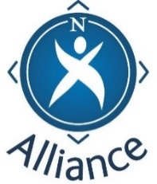 PROGRAMME

Family Learning – understanding the picture

This programme has been designed for partners involved in working with families. It presents a Community Learning and Development (CLD) picture of family learning and underpins the important role of partners working together in the interests of children, families and young people.

Location
Date
Time

Time | Activity | Lead
4.00pm | Coffee - Welcome and Introduction  Group introductions
4.15pm | Background – presentation  National picture  Policy position  Models of Family Learning
4.30pm | What do we understand Family Learning to be?  Group discussion – Resource Sheet 6
5.00pm | Roles and responsibilities  Group activity - Resource sheet 7
5.30pm | Highly effective practice – How good is our?  Discussion cards – links on screen - Resource sheet 9
6.00pm | Next steps for development and delivery of Family Learning in this locality/area  Evaluation - close

Outcomes sought:
- Build a clear understanding of the term “Family Learning”
- Build an understanding of roles and responsibilities in relation to Family Learning
- Strengthen networking of relevant professionals / partners in relation to Family Learning
- Begin to identify next steps in delivery of Family Learning in this area

