
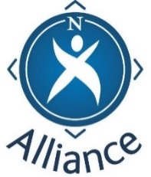

Feedback……………leading to next steps

How well have we met the outcomes set for this event? Please circle:
6 being fully achieved and 1 not achieved at all

1.Build a clear understanding of the term Family Learning

1 | 2 | 3 | 4 | 5 | 6

2.Build an understanding of the roles and responsibilities in relation to Family
Learning
1 | 2 | 3 | 4 | 5 | 6

3.Strengthen networking of relevant professionals/partners in relation to Family
Learning
1 | 2 | 3 | 4 | 5 | 6

4.Begin to identify next steps in delivery of Family Learning in this area

1 | 2 | 3 | 4 | 5 | 6

Please identify any areas of professional learning which could be strengthened in relation to Family Learning practice

Name – optional:

Please return to the event organisers

