
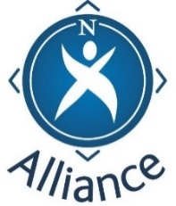 Resource pack

Family Learning – understanding the picture

This short introductory programme has been designed for partners involved in working with families. It presents a Community Learning and Development (CLD) picture of family learning and underpins the important role of partners working together in the interests of children, families and young people.

Use the programme to bring the relevant players together and to shape a clear approach to this important area of partnership work.

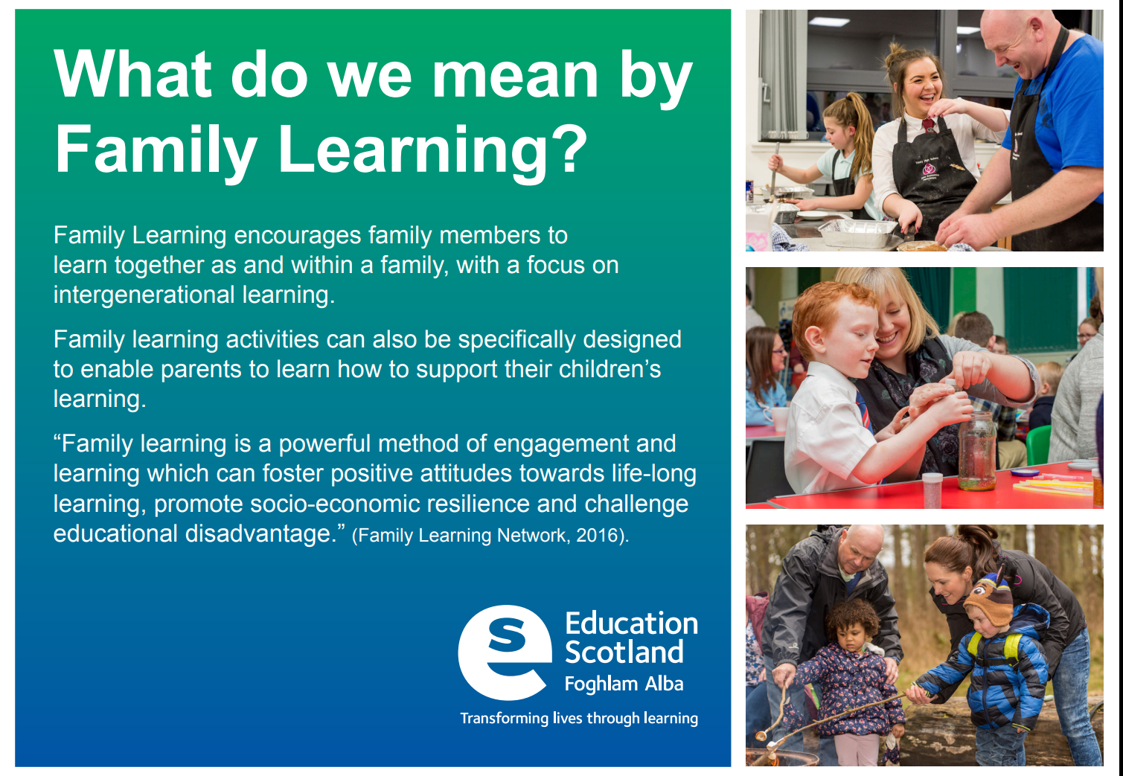

Pack contents

Family Learning – understanding the picture

No. | Resource
 | Pack Cover / contents list
R1 | FL Flier/poster
R2 | FL Programme
R3 | FL Sign In Sheet
R4 | FL PP Presentation slides
R5 | FL Sides – facilitator notes
R6 | FL Group exercise  What do we understand Family Learning to be?
R7 | FL Group exercise  Roles and Responsibilities in Family Learning
R8 | RIC Effective Practice slides
R9 | FL Group exercise  What helps identify good practice in Family Learning
R10 | Evaluation sheet
R11 | Handout  Developing social capital in Family Learning

