INVERCLYDE COMMUNITY LEARNING AND DEVELOPMENT
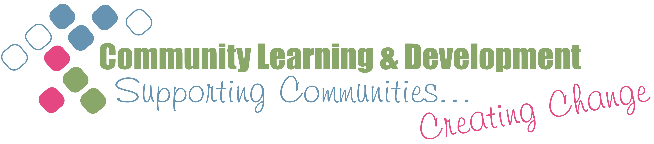
Ongoing Support for Literacies and ESOL Volunteer Tutor Assistants
1 Session visits
After a volunteer has completed Supporting Adult Literacies Learners (SALL) qualification and commenced their placement within a learning session(s), they are visited by a Named Support Worker (NSW) during their learning session or a meeting is arranged outwith the session for an informal chat regarding on how they settling in etc. Ahead of this meeting volunteers are asked to complete some paperwork which enables their previous skills and experience to be collated and used to build up a profile of the volunteers available to assist with this type of provision. See item 1 below. Prior to this meeting the NSW will also liaise with the member(s) of staff working alongside the volunteer.
These meetings continue on a regular basis for the duration of the volunteer’s time with the CLD Service.
2 Ongoing support
Volunteers are invited along to meetings of volunteers contributing across adult learning, as well as adult literacies and ESOL. The purpose of these meetings is to allow volunteers to meet up with each other, shares experiences, frustrations, resources etc and contribute to the development of the service. Minutes of minutes are circulated to all volunteers via e-mail.
The majority of communication between the NSP and volunteers is by e-mail as many work or are retired with other commitments and cannot always attend meetings.
Volunteers are also invited to SQA Meetings which gives them an insight into accreditation if they are supporting or thinking of supporting in the future learner on an accredited programme .
3 Training and Development
Training and development reviews are conducted every 6 months by the group tutor working alongside the volunteer. These are then collated by the NSP to identify any common areas of good practice as well as development.
As part of this review, volunteers are asked to complete a reflective record, commenting on their contribution to the provision, the learning and teaching strategies they apply with learners and the resources they use within the sessions.
One-off workshops are developed in response to the needs and interests identified by volunteers in their review sessions and through questionnaires completed by volunteers indicating areas of interest such as spelling strategies, numeracy etc. Volunteers are offered the opportunity to lead on these workshops. They can also visit other learning sessions delivered within the service and take part in one off workshops such as Internet Safety and Heart Start.
Volunteers are encouraged and supported to attain further accreditation for example, the Personal Achievement Award and the Conduct the Assessment Award.
Information about any other training opportunities both within and out with provision are e-mailed to volunteers (i.e.: from GCVS, Glasgow ESOL Forum, Dyslexia Scotland etc)
As part of the ongoing support and review process, impact statements are gathered from both the volunteers themselves and the learners they support and via ongoing informal discussions within sessions and with group tutors. Not only do these assist the volunteers to reflect on their own learning and skills development, they provide a valuable way to recognise the contribution of volunteers. During Volunteers Week plaques are presented to volunteers by the learners themselves and by representatives from the Adult Learners Forum in Inverclyde (ALFI). The impact statements are also included in a special newsletter produced for Volunteers Week.

