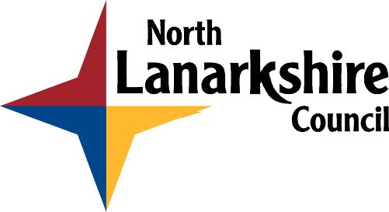

LEARNER REVIEW

Learning: Adult Literacy and Numeracy / ESOL

Name: Date:

What was your goal this term? | Have you achieved your goal?  YES / NO
What learning have you taken part in? (check your ILP/work plan)

What have you learned? ? (what can you now do at home, at work, at college…?)
(See over for four areas of life.)

Do you feel more confident about your learning?

What did you enjoy about your learning this term? What was a good way of learning for you?

Was there any part of your learning you did not enjoy? If not, why not?

What would you like to do next?

FOUR AREAS OF LIFE

How has your learning made a difference? How have you used what you have learned?
You do not need to fill in every box.

Community Life

Family Life

Private Life

Working Life

