
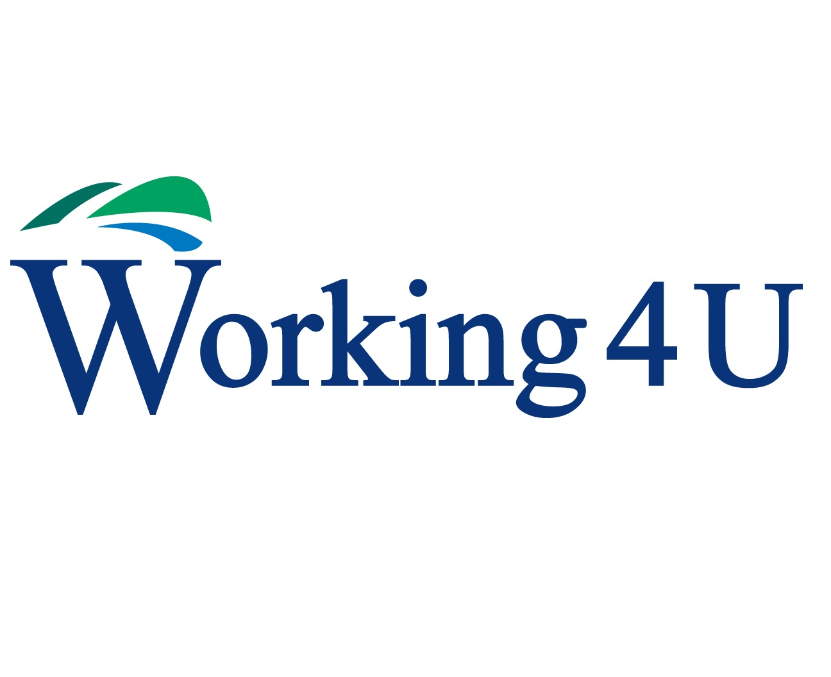
PEF Opportunities

Contents

Working4U introduction

Youth Learning

- Dynamic Youth Awards
- Enhanced Experiential Learning
- Issue Based Tailored Programmes
- Pupil Council/Student Voice

Family Learning (Example projects)

- Pocket Money Challenge (Linnvale Primary School)
- Fit Families (Our Holy Redeemer Primary School)
- Family History Project (Linnvale Primary School)
- Memory Lane (St Peters Primary School)
- The Very Hungry Caterpillar (Haldane Primary School)
- Ready Steady Atbakh (Linnvale Primary School)
- The Story of Us

Work & Money (parental support)

- Drop in’s –Employability support and Money Advice

Contacts
Clare.English@west-dunbarton.gov.uk
Billyjoe.Mclaughlin@west-dunbarton.gov.uk

Working4U

Working4U seeks to address the underlying causes of poverty, as well as the symptoms, by specifically tackling unemployment, providing opportunities to increase levels of education, skills, confidence and personal development as well support to claim in and out of work benefits and manage debt.
Working4U aligns the work of three service areas - Employability, Community Learning & Development and Advice Services. West Dunbartonshire residents and communities now have a single gateway to services on Work, Learning and Money.

All of the Working4U Opportunities detailed are flexible and can be adapted to meet the needs of the school and/or tailored to meet the needs of targeted pupils and their families.

*Many of the courses can be provided through the Working4U’s Service Level Agreement with West College Scotland. If learners are eligible for fee waiver and attend for 25% + 1 of the course, their fees as paid through our partnership agreement, which draws down funds from the Scottish Funding Council. If any learners are not eligible or drop out before the 25% + 1 attendance, then there would be a cost to the school.

Youth Learning

Working4U Learning support the ethos that having qualified Youth Work staff working directly with pupils enhances the learning offer to young people and ultimately improves young people’s attainment and achievements levels. In partnership with schools and utilising the Equity Funding, Working4U Learning can enhance this offer and achieve positive outcomes for young people.

Youth Work empowers young people, widens their horizons and builds their resilience and capacity. Using an interventionist approach, youth work supports young people who are facing the consequences of inequality and disadvantage.

As informal educators, our staff work with some of the hardest to reach young people in our communities using a Youth Work approach and regularly work and engage with young people who are school refusers, have low attainment rates, suffer from low confidence and self-esteem and those who are disengaged from school

“If the belief is held that each part affects the whole, it can clearly be seen that good youth workers cannot only aid young people in working towards transforming their lives, they might also make inroads towards the transformation of society itself”.
(Rosseter, 1987).

Dynamic Youth Awards

Dynamic Youth Awards provide a framework to support quality work with young people. They offer recognition and accreditation for young peoples’ achievements. The Awards follow a Plan-Do-Review process which enables young people to more effectively recognise and articulate their learning and achievements within different contexts. The Dynamic Youth Awards can be introduced to accredit activities they are already involved in. This increases their self-esteem, improves motivation and keeps young people engaged with learning. Through self and peer assessment young people develop skills for learning, life and work. The Awards fully support the aims, values, purpose and implementation of Curriculum for Excellence.

• Are for young people age 10+
• Have a minimum 5 hours of time commitment
• Have 5 levels (Star Rating) based on the young person’s cumulative hours
• Can be incorporated into existing or planned activities
• Can be used in a range of settings
• Are inclusive and suitable for young people with a range of interests and abilities
• Are externally quality assured by Scottish Qualifications Authority (SQA)
• Are credit rated on the Scottish Credit and Qualifications Framework (SCQF) where they sit at level 3
• Help to evidence Outcomes
• Support further learning opportunities within Secondary Education (credit points achieved in primary school contributing to partial completion of Bronze Youth Achievement award in secondary school)

Based on minimum programme length.

Enhanced Experiential Learning

This programme is designed to enhance W4U’s current successful Experiential learning programme delivered to all primary 7 pupils across the authority, themed around Community Safety, Fire Safety, First Aid, Litter Control, Rail Safety, No Knives better lives, drugs and alcohol awareness, Water Safety and serious & organised crime. Programme will extend pupils knowledge on the themes learned and could also be extended and tailored to pupils across all primary levels. Outcomes include:

• Increased understanding of community safety issues affecting young people.
• Young people better to articulate their understanding of community safety.
• Wider awareness of emergency and non-emergency services.
• Pupils will have positive contact with arrange of services involved in community safety.

Based on 10 week programme.

Issue Based Tailored Programmes

Working4U can work with schools to deliver a variety of issue based tailored programmes, to highlight/tackle issues relevant to young people, or work with pupils with identified needs to support their engagement with the school curriculum. This could include:

• Bullying
• Confidence/self esteem
• Motivation
• Relationships
• Sexual health
• Drugs and alcohol
• Others depending on school need.

Programmes can be developed around raising awareness, school campaigning, community projects and incorporate; Self-management; Problem solving; Resilience; Communication skills: Positive attitude; Team working and much more depending on school need.

Based on 10 week programme.

Support to Pupil councils/student voice

(Pupil representations groups)

This programme can be created to educate & engage young people in their school community & in the active citizenship agenda. The programme will provide pupils with an understanding of the Rights & Responsibilities of citizenship in a democratic society, how to engage & represent their schools community & will equip pupils with the skills necessary to become an effective contributor.

Programme can include sessions on:

• Youth Representation Skills
• Consultation skills
• Committee skills
• Public speaking skills
• Debating skills
• Communication skills
• Children’s rights
• And many more

This programme can support the development of new school committees or ones that already exists e.g. pupil council, eco committees, Rights respecting school etc. The programme can also be adapted to support the development of Parent councils.

Based on 10 week programme.

Family Learning

Parents, carers and families are by far the most important influences in a child's life. Their support can play a vital role at all stages of education.
Parents who take on a supportive role in their children's learning make a difference in improving achievement and behaviour. The active involvement of parents can help promote a learning community in which children and young people can engage positively with practitioners and their peers. Parental engagement is recognised in the National Improvement Framework as one of seven key drivers in achieving excellence and equity in Scottish education. The engagement of parents and families can help raise attainment for all and help to ensure every child has an equal chance of success.
(Education Scotland)

'Family learning is a powerful method of engagement and learning which can foster positive attitudes towards life-long learning, promote socio-economic resilience and challenge educational disadvantage.' (Family Learning Network, 2016).

Many adults with the lowest levels of literacies report that, as children, they received little support or encouragement in relation to education. Family learning is an investment in Scotland’s future, as it contributes to equality of opportunity by changing learning patterns within families. Working with the family together rather than with the child or the adult separately can often make a greater impact on the development of both child and parent or carer. This can be achieved by combining early interventions and early parenting strategies with adult literacies work and adult learning. Parents and carers who develop their own learning often gain confidence and skills to help their children, which can create a home learning environment and promote lifelong learning for all.

With this in mind Working4U Learning, West Dunbartonshire Council has designed and developed a range of family learning projects which have been delivered across the authority in nurseries and primary schools. All the projects have been planned and evaluated and can be adapted for use in a variety of locations & contexts.

Pocket Money Challenge

Learners designed & developed an active floor game which evolved from the idea behind Working4U Money’s board game, Pay Day Challenge, to promote financial awareness. Parents & children from Linnvale Primary School worked together to develop the game called Pocket Money Challenge. Every child in the school was involved in creating three different versions of the game ensuring that the questions, challenges and activities involved in the game were age appropriate for all stages of the school. Parents & children learned about the interest rates involved in borrowing money from a variety of sources & promoted pupils’ membership of Credit Union.

The project was delivered within the framework of a SQA ‘Working with Others’ unit. The Unit requires learners to: -

• Identify the main roles which make up the activity and/or activities, the individual’s role, and the roles of others
• Work co-operatively to identify the relationships between the roles which make up the activity and/or activities, adapting own role as necessary
• Actively seek, and/or provide, relevant and appropriate support from/to others

Each parent who completed the course received a level 4 SQA qualification.

Fit Families

Fit Families was evolved following on from many outreach visits and discussions with parents & the head teacher at Our Holy Redeemer Primary School in Whitecrook, one of the highest SIMD areas in West Dunbartonshire. Parents complained that it was often difficult to cook a healthy homemade meal on a budget and often their children preferred to eat junk food. They worried that their children were not getting their ‘five a day’ fruit and veg and that their children were not nearly as active as they themselves had been as children.

It was decided that a pilot programme called Fit Families would run in partnership with Active Schools and CAOS the local community arts project. The pilot would run for 13 weeks delivering 6 cookery & nutrition sessions, 3 dance sessions & 4 sports sessions with Active Schools.

The cookery nutrition sessions focussed on healthy cooking using less salt, fat & sugar while on a budget. Parents and children cooked together and participated together as a family in the sport/dance sessions. It was agreed that by combining resources each of the agencies would be delivering a far better end product than would be possible individually.

Parents & children worked together to acquire basic cookery skills. Participants learned how to make healthy packed lunches and cook family favourites using less salt sugar & fat, while on a limited budget.

The programme also encouraged families to participate together in sport & dance activities, with 4 family sport sessions & 3 family dance sessions. Parents & children benefited from spending time and sharing activities together.

Family History Project

To mark the 60th Anniversary of Linnvale Primary School a group of parents took part in the Linnvale Family History Project within the context of an SQA Personal Development, Self in Society course. The course improves self-reliance and self-esteem by setting targets for the development of interpersonal skills while working in a group to plan & carry out a project while gaining a vocational qualification.

The course was delivered in partnership with Clydebank College as part of the local Service Level Agreement (SLA).

The Linnvale group researched the history of Linnvale particularly Linnvale Primary School as part of the commemoration events & worked with school pupils, CAOS and WDC libraries research staff to create a mural of the school’s history and a commemorative calendar. Within the school, 57 pupils in P6 & P7 also researched the area’s history and pupils and parents worked together to produce the mural. The mural depicts not only Linnvale, but Clydebank as a whole, past & present as well as historic events, inventions & public figures throughout the last sixty years.

Memory Lane

St Peters Primary School is situated in Bellsmyre, Dumbarton which is one of the highest SIMD areas in West Dunbartonshire Council. The area was undergoing a period of massive regeneration, including new housing, two new primary schools and a new secondary school. The learners decided to create a ‘memory lane’ commemorating the school’s history. This was delivered as part of a personal development course culminating in an exhibition which was opened for viewing to the Bellsmyre community at the school fete in mid-June prior to the school’s closure & relocation to the current Aitkenbar Primary School site. The main corridor walls in the school were cleared to accommodate the memory lane which consisted of narratives, images and statements reflecting the five decades of the school’s history.

11 adults took part in the programme. All of the P7 pupils took photographs and wrote statements for the memory lane and all of the school’s pupils created images for a commemorative tea towel.

The Very Hungry Caterpillar

This Project uses the well-known children’s story book The Very Hungry Caterpillar as a catalyst to engage families in various learning opportunities involving reading, creating art and cookery, encouraging parents and children to spend time and learn new skills together. This story book was chosen because of its colourful appeal and content around food and the science of metamorphosis which the children were learning about at nursery. The activities encompassed Curriculum for Excellence (CfE) outcomes in Health & Wellbeing - Nutrition & Parenthood, Sciences - Planet Earth & Expressive Arts - Art & Design.

Course Programme

• Families read together to learn about the process of metamorphosis from caterpillar to butterfly and the impact certain food choices can have on one’s wellbeing.

• Families worked and played together to create either a frieze or sculpture representing the Very Hungry Caterpillar.

• Families learned together about nutritious food choices. The Eat well plate was discussed and families took copies home as place mats.

• Families worked together to acquire basic culinary skills by learning how to make healthy meals and snacks using less fat, salt and sugar while on a budget. The children learned how to chop fruits and vegetables safely, how herbs and spices can flavour food and most of all how cooking and eating together is fun and easy.

• Families took home a selection of recipes from a cook book on healthy eating on a budget and a measures and weights convertor chart

Ready Steady Atbakh

Six Scottish parents and six Syrian parents & their school age children took part in the project. Food is such a great way of showing & giving friendship. You can learn so much about someone from cooking with them. Teaching younger generations how to cook and interact with food allows them to engage with their culture. Sharing food and cooking techniques gives people a chance to learn about your culture and provides a thread for connecting people from very different places.

With this in mind it was agreed with Linnvale Primary School and the parents that a cookery programme where Scottish & Syrian families would cook & share food would be a great opportunity to promote positive relationships.

Linnvale Primary School provided cooking facilities and their catering manager provided tremendous support, ordering food & fresh produce from halal suppliers. West Dunbartonshire Council provided interpreters for the planning meetings, local training company Raising Standards delivered REHIS food hygiene training and the project was funded by Provost Douglas McAllister via West Dunbartonshire Council’s Provost Fund.
West Dunbartonshire Libraries will also be involved in the follow up programme.

Benefits for Participants:

• Improved knowledge of food safety principles
• Improved sense of belonging within their current community
• Improved knowledge & understanding of other cultures
• Improved knowledge in the use of ingredients & equipment
• Improved cooking skills
• Improved child parent relationships

Each participant received a qualification in food hygiene. Parents & children prepared a meal typical of the kind of evening meal they would prepare at home and shared it with the other participating families heightening knowledge of other cuisines. The English language skills of Syrian parents increased. Knowledge and understanding of another culture and way of life increased. Over the 2 planning and 4 cooking sessions friendships were formed and a desire for further learning developed.

The Story of Us

The theme of the project is identity, place & belonging. Parents & children will take part in a family learning project , in which each child, helped by their parents, will create their own book about their lives in (for example) Clydebank over the period of an academic year, highlighting their home, friends, school and community in the context of significant events throughout the year.
Families will:
- Improve their knowledge of local environment, people & past events
- Improve their skills in finding & using information
- Improve skills in recording information

Once a month the families will meet together, often sharing a meal that has been planned, costed and prepared by two of the families, working together. The families can choose to make whatever they want within a set financial amount and with upper limits on fat, salt & sugar content. All participants will complete a food hygiene course. This will be a REHIS certificated course for parents and a junior version for the children.
Parents who complete the programme can be awarded a SQA Working With Others qualification at the appropriate level. This is a core skill unit which focuses on transferable skills:
- Carrying out an activity and/or activities co-operatively with others;
- Reviewing co-operative contribution.

These skills should be useful to parents in their in their social and personal lives, or in current and future jobs. At this level, learners are expected to be able to work with others in simple activities where they may need support at all stages of the activity and/or activities. The Unit is designed for those who have little or no skill and experience in working with others.
A Working4U Development Worker would undertake: planning, monitoring and evaluation, including regular meetings with school staff, linking to How Good is … and liaising with school in terms of input to Curriculum for Excellence for the children; organising of overall programme and individual sessions; delivery and assessing of Working with Others unit for the Adults; support learners, including providing guidance; link with Adult L earning and Literacies Team in terms of exit guidance; support delivery staff/tutors.

Work and Money

(Parental support)

Working4U can provide a drop in service delivered within the school; parents will have access to a Working4U Officer who will focus on their employability and training needs.

This will include:

- Employability needs assessment and action planning
- Barrier identification and removal
- Accredited vocational training based on employer need, work related activity and employability skills development
- Employer engagement, job brokerage activity
- In-work after care, support and progression
- Access to West Dunbartonshire wide provision WD Strategic Skills Pipeline

Parents will then have access to wider Working4U Opportunities:

- Employer recruitment incentives,
- 25+ apprenticeship opportunities,
- Sector specific training e.g. Construction
- Skills Academies
- IT up skilling
- Confidence building
- Money management and debt advice – income maximisation including; benefits; debt; budgeting and financial capability learning.

If schools have specific requirements around employability programmes for parents we can also discuss.

Contacts
Clare.English@west-dunbarton.gov.uk
Billyjoe.Mclaughlin@west-dunbarton.gov.uk

