Invitation To Tender

Sharing Lives, Sharing Languages

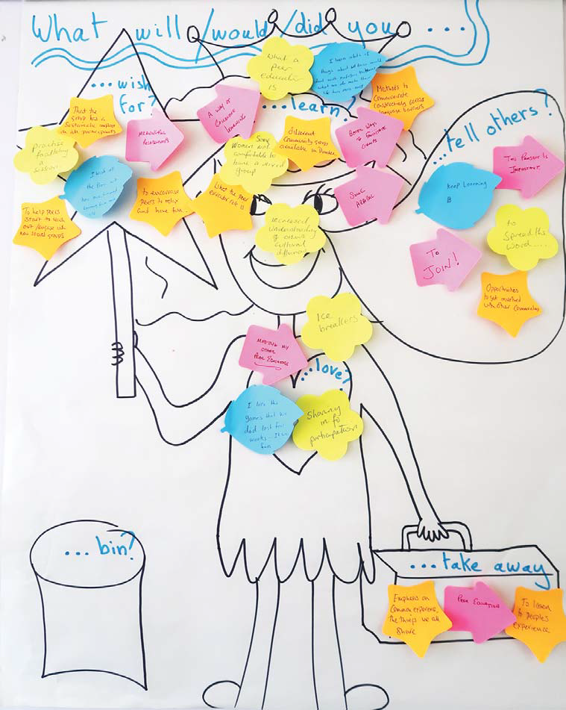

A deliverable of the Scottish Refugee Council New Scots Integration: Rights and Communities project funded by the EU Asylum, Migration and Integration Fund (AMIF)

1. Introduction

Scottish Refugee Council (SRC) is a Scotland-wide national refugee support charity. In addition to providing ongoing direct support, advocacy, and advice to refugees and asylum seekers in Scotland, SRC works to enhance refugee protection and integration policy and practice in the UK and worldwide. Our objective is ‘building a better future with refugees in Scotland’. Our vision is for a Scotland in which all people seeking refugee protection are welcome; a place where women, children and men are protected, find safety and support, have their human rights and dignity respected and are able to achieve their full potential.

As part of New Scots Integration: Rights and Communities project, Scottish Refugee Council are seeking tenders from organised community groups across Scotland to apply for funding to deliver a peer education project which enables refugees to build social connections with the wider community, improve cultural orientation, increase language practice and build employability pathways.

2. Background

In July 2018 Scottish Refugee Council secured funding from the European Union Asylum, Migration and Integration Fund to undertake a two-year project, New Scots Integration: Rights and Communities, which aims to ensure refugees are effectively integrated into Scottish society and able to achieve their goals and have their needs met; while communities are supported and prepared to welcome refugees and involve them in community life. The project is delivered in two work streams. Work stream 1 concentrates on individual needs and rights, whilst Work Stream 2 works with communities particularly refugee-led communities, receiving communities and faith-based groups working with refugees and asylum seekers.

One of the deliverables from Work Stream 2 is to establish a number of peer education projects using the Sharing Lives, Sharing Languages (SLSL) pilot project as a starting point. Sharing Lives, Sharing Languages is a successfully piloted and evidence-based peer education project that provides a structured intervention and model for community groups to support refugees to build social connections with the wider community, improve cultural orientation, increase language practice and build employability pathways. The New Scots Integration: Rights and Communities aims to roll out this pilot with 8 community groups in 8 local areas across Scotland, expanding the timeframe and breadth of the original pilot to act as a best practice template for how communities should organise integration activity. Monitoring of individuals’ social connections and integration outcomes and evaluation of effectiveness of project delivery are integral parts of the Sharing Lives, Sharing Language project.

The SLSL pilot aimed to increase the social connections and opportunities for non-native English speakers to use their English outside the classroom. It used a peer education model and complements the current local authority English as a Second or Other Language (ESOL) provision by providing opportunities for peers and their peer educators to meet local people and practise their English in a natural setting. The project proved very successful in facilitating cross-cultural communication as it allows native English speakers and non-native English speakers to share their lives and their languages with each other.

The independently produced SLSL Pilot report made the following conclusion which led Scottish Refugee Council to seek funding to continue this type of project. “All peer groups have found the experience of the Sharing Lives, Sharing Languages project very rewarding and inspiring. Peer Education Co-ordinators (PECs) in each of the four primary localities have identified clear pathways for supporting the groups’ future. Peer sessions continue beyond the publication date of the present report and PECs are making local arrangements for groups to continue their activities. A Syrian peer is also looking into coordinating a women’s crafts group based on her experience with the peer education model. According to Peer Educators’ experiences, the Sharing Lives, Sharing Languages project already has all the necessary components to be a sustainable project. The degree of informality within the groups, the creative structure behind the programme, the engagement of people from different cultural and linguistic backgrounds, and the emphasis on peer support are all valuable assets that will enable the programme to thrive in a wide range of communities. The many achievements of this pilot project demonstrate its strengths and future potential.“

It is recommended that you read the Sharing Lives, Sharing Languages Pilot Report before submitting your tender:
http://www.scottishrefugeecouncil.org.uk/assets/0001/4110/Sharing_Lives_Sharing__Languages_REPORT.pdf

3. Tender Specification
Scottish Refugee Council are seeking tenders from organised groups working with refugees who would like to take part in delivering one of the eight Sharing Lives, Sharing Languages projects as part of New Scots Integration: Rights and Communities.

3.1 Project Definition
Establish a project to setup and operate a peer education programme which conforms to the Peer Education Model and Operational Peer Education Model described on Pages 5 and 75 of the Sharing Lives, Sharing Languages Pilot Report (and included in Appendix A below). This seeks to build social connections with the wider community, improve cultural orientation, increase language practice and build employability pathways: or a project based upon a similar approach or with similar objectives. The project should deliver maximum benefit to the peer participants, particularly refugees and asylum seekers by building on the recommendations of the Pilot project, particularly those related to Expanding Social Connections (Page 71 of the Pilot Report).
3.2 Project Duration and Start-Up
The project must operate for 12 months and must end by the 10th May 2020. A maximum project start-up phase of one month is included in the project duration. A formal appraisal and sign off of the project start-up will be undertaken by Scottish Refugee Council using the evaluation criteria identified in Appendix C. On successful sign-off of the start-up the second tranche of funding (25%) will be paid.
3.3 Project Area
Projects can be established in any part of Scotland and you will be required to provide details of the area (i.e. which county, city, town, ward, district etc.) you will operate in and an indication of the number of anticipated participants. If there are bids which have duplicate or overlapping areas these will be treated competitively.
3.4 Project Ethics
You must comply will all relevant General Data Protection Regulations (GDPR), particularly those related to media and images. If you intend to work with vulnerable groups please detail that you conform to Protecting Vulnerable Groups requirements.
3.5 Project Reporting
Each project will be required to produce a report every three months covering financial, statistical and evaluation information (as defined in Appendix B below). A closing report must be presented by 31st May 2020.
As a condition of the tender, the third tranche (50%) of the allocated funds will be paid after 6 months, from the start of the project, subject to Scottish Refugee Council scrutiny of expenditure to date as detailed in the 2nd report cycle. The delivery date for this 2nd report will be agreed at the end of the start-up phase. Scottish Refugee Council reserves the right to reduce the allocated funds if the reporting requirements are not met or there is a significant underspend.
3.6 Project Management
Whilst formal project management of the project is not a requirement of the tender, it should be understood that planning and control of personnel and events will be a necessary part of the project in order to deliver the best opportunities for the refugee participants and to meet the contractual reporting and financial requirements. An outline of how you will ensure these control procedures are established and operated should be included in your tender.
3.7 Project Outputs
For the peer participants in your project, we hope the outputs are as varied, innovative, interesting and successful as you can make them. Scottish Refugee Council, however, will require the reports described in Section 3.5 Project Reporting above. These must be presented to a schedule which will be agreed during project start-up. In addition, the appraisal and sign-off of the project start-up will require the production of evidence as identified in the evaluation criteria (Appendix C).
To demonstrate success and document increasing social connection and integration activities, please take every opportunity to record video clips and images. You will be able to upload these to the National Digital Platform (New Scots Connect) which Scottish Refugee Council is developing
3.8 Project Support
As part of the New Scots Implementation: Rights and Communities project, Scottish Refugee Council has established a network of Regional Integration Co-ordinators, who with the aid of the National Faiths-Based Co-ordinator, will provide on-going contact, advice and support to the SLSL projects and act as a communication channel to ensure awareness of good practice, tools and techniques.
3.9 Project Key Dates

Tender closure date | 5th May 2019
Decisions made by close of business | 10th May 2019
Official Project start date | 13th May 2019
Project start-up phase complete | 10th June 2019
Mid-project review | Week commencing 11th November 2019
Official Project end date | 10th May 2020
Closing report presented by | 31st May 2020
Project Presentation Day | To be confirmed

3.10 Project Presentation
Scottish Refugee Council will also require your attendance at an event to be held once all the SLSL projects are completed. At this event, we would like a member of your group and a refugee participant to:
- present your project to the other projects, including video clips and images of successful activities, and
- to discuss and agree a ‘toolkit’ of good practices for future community groups to use to further the concept and practice of ‘peer’ learning in their communities, and
- to celebrate your successes.
Travel expenses will be available for a project member and refugee participant to attend and a more detailed brief for the presentation and agenda for the day will be presented nearer the time.

4. Format of Bid Submission
The bid must include:
- A description of your group.
To cover information about your group (e.g. what type of group you are, where you are based, number of members, group bank account details, what you do, how many refugee families you support etc.) sufficient to give us a good appreciation of your background and capabilities. In addition, provide details of the skills and experience of the group members who will be involved in the project. If you intend to involve partner organisations or contractors in the delivery of your approach, please provide details of the organisation/individual and what role they will play.

- An explanation of how the proposed approach meets the specification.
Explain how your proposed approach will meet the specification defined in Section 3 above.
- If you are going to follow the Peer Education Model, please indicate whether you require Peer Education Co-ordinator training or not. If required, Scottish Refugee Council can arrange to train your Peer Education Co-ordinator(s).
- If you do not wish to follow the Peer Education Model, provide details of your approach and especially how it will meet the expected outcomes for the refugee participants over the 12 months of the project.
- If you already operate a project which involves peer learning in the community which improves social connection, language improvement and integration and want to expand this, particularly in some of the ways recommended by the SLSL Pilot Report, then please consider applying for a grant. Scottish Refugee Council will consider your proposal providing it runs for 12 months and meets the finance and reporting criteria.

If you propose to implement any of the recommendations from the SLSL Pilot, please detail which recommendation(s) and describe what you intend to do and how you will evaluate success.

You should pay particular attention to the management, reporting and financial requirements of the project specification and describe how you will meet these requirements.

Please clearly identify the area of Scotland you will be active in and indicate, to the best of your ability, the number of refugee and peer participants you will involve.

- Ethics and data protection considerations.
Detail how you will ensure conformance to General Data Protection Regulations, particularly for images and media. Indicate whether Protecting of Vulnerable Groups membership is required and that the group members active in the project are registered.

- Timescales for completion of the work.
Please indicate your acceptance of a 12 month project with a maximum of 1 month start-up phase.

- Budget which must be inclusive of VAT.
Please detail your proposed expenditure in the following categories.

Category | Sub-category | Amount
Staff / personnel | Costs of Group members in delivering project
 | Costs of partners/contractors involved in delivering project.
Travel | Costs for Group members, partners or contractors if require.
 | Costs for peers and refugee participants.
Organised Participant Activities | Costs for venue hire, materials, refreshment.
 | Total

- Relevant experience.
Please provide details.

5. Bid Selection criteria

Bids will be evaluated and selected against the following criteria:
- Fitness for purpose (quality).
- Skills and Knowledge - as appropriate to the work required.
- Value for money.
- On-going maintenance and running costs – if applicable.
- Statutory Requirements (The tenderer should be legally able to work in the UK with a relevant tax reference number).
- Deliverability.
- Availability.
- Ethics, Data Protection and PVG considerations.

6. Further information

To ensure fairness and transparency during the bid period, no further information will be given.

7. Instructions to return Tender

Please send your tender in an envelope clearly marked “Tender” and “For the attention of the HFCS” or by email to the HFCS directly, clearly marked “SLSL Tender” in the subject line.
Kes Cameron
Head of Finance and Corporate Services
Scottish Refugee Council
Portland House
17 Renfield Street
Glasgow G2 5AH

E-mail: kes.cameron@scottishrefugeecouncil.org.uk

8. Deadline date for submission of tenders.

Tenders must be submitted by 11:59pm on Sunday 5th May 2019.

9. Terms and Conditions

The bidding group, and any partner organisation in receipt of funds from the Scottish Refugee Council, must be legally able to work in the UK with a relevant tax reference number. In addition, individuals or contractors working on your project who receive funds from SRC must be legally able to work in the UK.

Please ensure you provide your group’s bank account details on your bid document.

Scottish Refugee Council’s standard terms and conditions will apply.

Scottish Refugee Council does not bind itself to accept any or all of the bids submitted in response to this tender.

10. Payment Schedule

The maximum funding you can apply for is £12,750 inclusive of VAT.

Subject to invoices, the work will be paid in three instalments:

- 25% following notification of successful bid;
- 25% on successful start-up of the project;
- 50% 6 months after the first payment, subject to meeting project reporting requirements and Scottish Refugee Council scrutiny of expenditure to date.
APPENDIX A – Peer Education Models

The Peer Education Model

- Peer Educator Coordinators (PECs) received training and identified Peer Educators (PEs) in their local communities to help form peer groups.
- PECs delivered training sessions to PEs who learned about the peer education model, the project’s objectives and outcomes, and strategies for peer engagement and learning.
- Each peer group conducted a series of peer sessions which explored the participants’ social connections, group and individual needs, common interests and hobbies and ideas for collective actions.
- Each peer group planned and conducted collective actions which helped peers to expand their connections with the wider community and to practise their language skills.
- Peer sessions continue beyond the collective actions with a plan to identify new needs, group activities and future collective actions.

The Operational Peer Education Model

The peer groups were actively engaged in finding strategies, activities and approaches that worked effectively across language a cultural barriers. The peer education model and the appreciative inquiry approach have been essential in facilitating group work and peer support. Drawing upon the activities, suggestions, and practices of peer groups in primary locations and the groups in comparative local authority areas, the following peer education model could be used to support future peer groups:

The proposed model builds on the same principles of peer education, involving at its core PECs, PEs and peers from a wide range of cultural and linguistic backgrounds. The model provides more guidance in the types of activities and strategies that would best support the development of social connections and language learning:

Experiences – Peer sessions will focus on supporting peers through group experiences. Experiences could include peer sessions at the railway station or at the library. In the pilot project, peers appreciated being out in the community, on various locations where language and social connections could be explored on site.
Artefacts – Peer sessions will focus on sharing and discussing artefacts, including cultural objects, tools, personal objects, crafted objects, etc. A focus on objects generated rich conversations in some of the peer groups and encouraged the participation of all language learners.
Collective Actions – Peer sessions will plan collective actions. Collective actions involve a multistage approach to planning, organising and engaging in group activities. These events allow the participants to actively use languages, to make a difference in their communities, and to enhance the connections established in the group.

Examples of activities carried out in each group in the four primary local authorities and presented in this report demonstrate that experiences, artefacts, and collective actions have been integral dimensions of the pilot project. Peer feedback also points to the many positive outcomes that future groups may experience if they were to implement the proposed model.
APPENDIX B – Reporting Requirements

Finance

For each sub-category, please detail expenditure in the reporting period (2 months) and project to date total. All amounts should be inclusive of VAT.

Category | Sub-category | Period Amount | Project To Date Total
Staff / personnel | Costs of Group members in delivering project
 | Costs of partners/contractors involved in delivering project.
Travel | Costs for Group members, partners or contractors if require.
 | Costs for peers and refugee participants.
Organised Participant Activities | Costs for venue hire, materials, refreshment.
 | Total

Statistics
To evidence the impact of this project, information will need to be gathered from organisers and participants attending the programme. Statistics will need to show that:

• 80% of participants will have increased knowledge of local area and access to facilities.
• 80% of participants will have increased confidence in social interactions.
• 80% of participants will be proficiently literate individuals.
• 50% of eligible participants will be more employable.

Support will be provided by the Monitoring and Evaluation Officer at SRC to help you gather this information.

In addition, simple metrics to cover the number of events, number of participants (including their demographics, i.e. age, gender, education level etc.) and the type of activities undertaken will be required. A template for this information will be available if required.

Evaluation

Throughout your project, training evaluations will need to be carried out at different stages, this will also contribute to the statistics required to report on the project. Questionnaires will be carried out at the start and end of the project, as well as recording and collecting evidence (e.g. photos and artefacts) during the programme of activities. Support for this part of the project will be provided by the Monitoring and Evaluation Officer at SRC. Case studies must also be collected. The exact evaluation process, dependant on your project approach, will be defined during the project start-up and agreed at the part of the start-up review.

APPENDIX C – Project Start-Up Evaluation Criteria

Project Start-Up criteria | Evidence Available
Project staff, partners and/or contractors are in place and trained.
Procedures are in place to meeting scheduled financial, statistical and evaluation requirements.
Evidence of any local promotional / publicity to increase community awareness and involvement.
1st “peer education” activity planned – i.e. objective, date, time, venue, attendees, anticipated number of participants.
Agreed Date for delivery of 2nd financial and statistical report. | dd/mm/yy

A deliverable of the Scottish Refugee Council New Scots Integration: Rights and Communities project funded by the EU Asylum, Migration and Integration Fund (AMIF)

