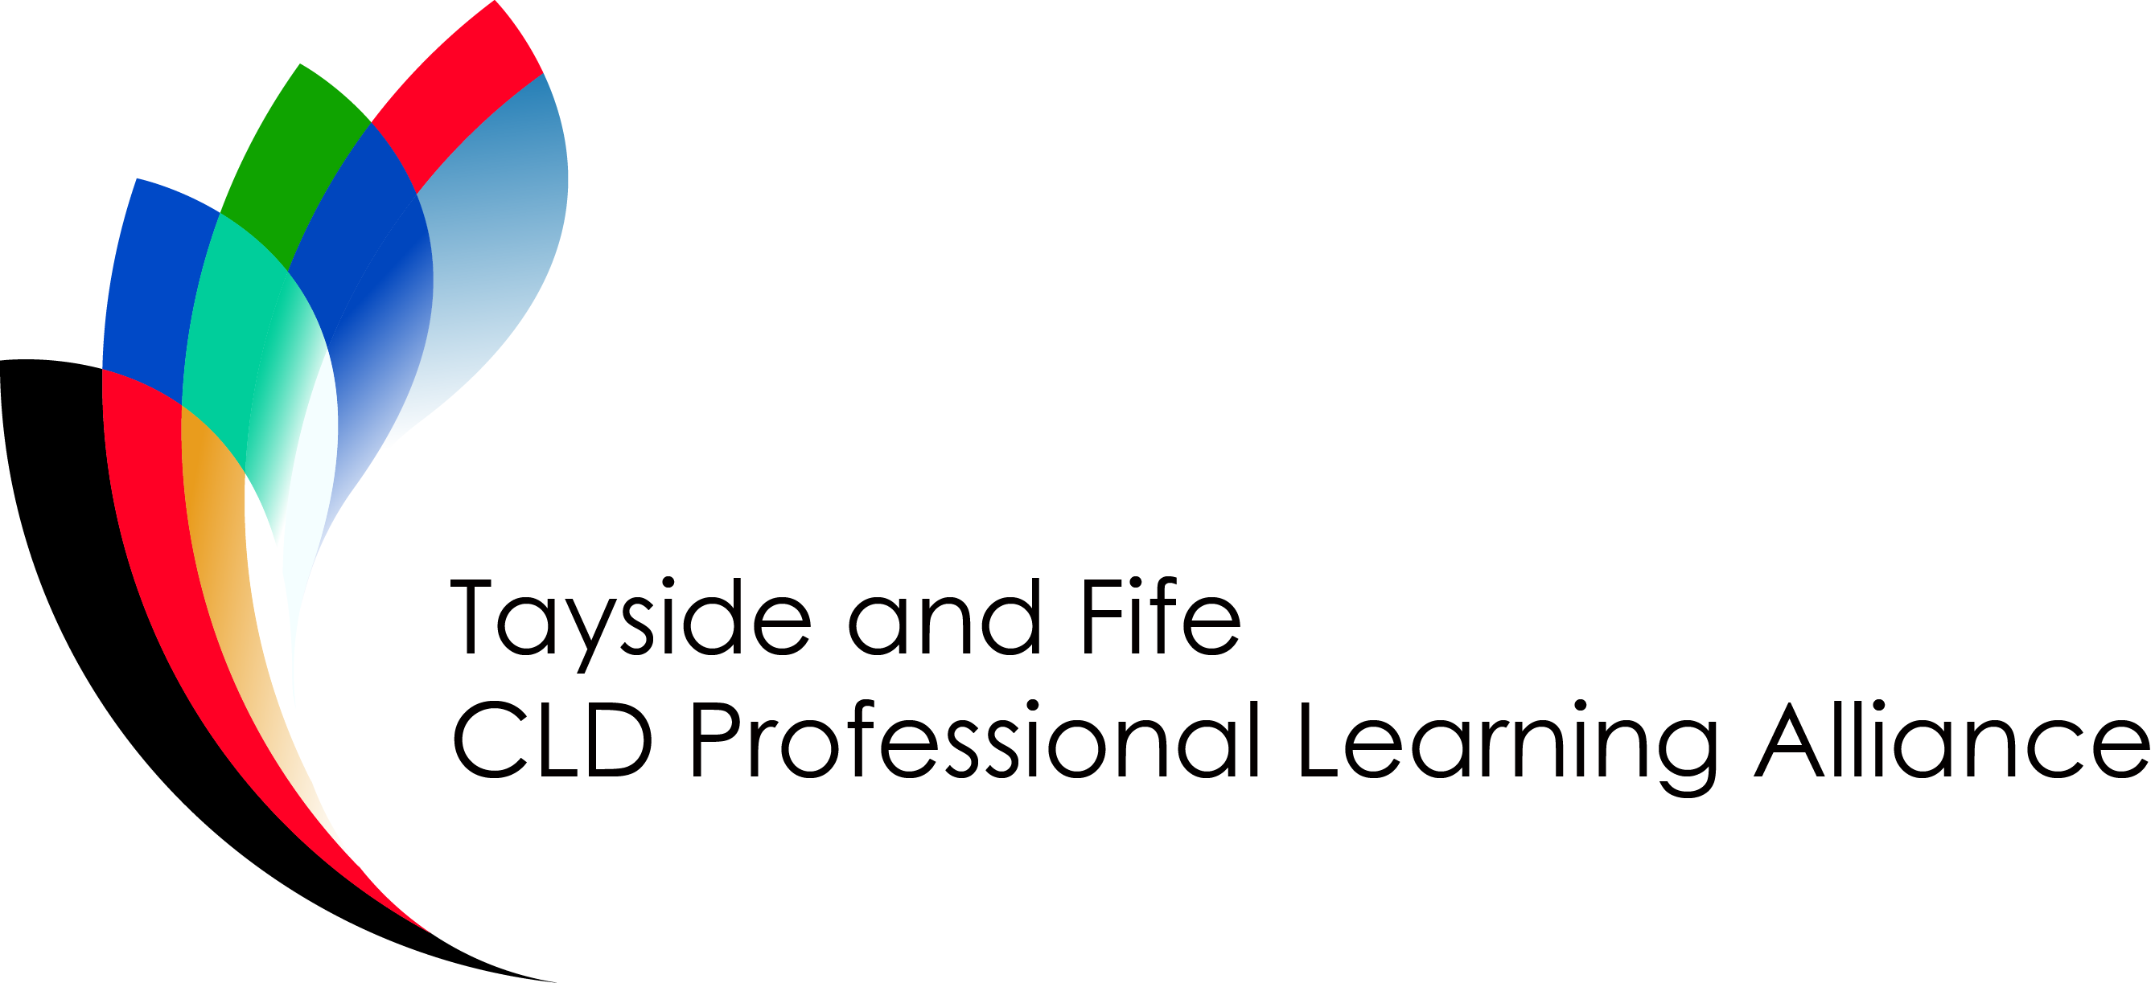
‘Family Learning in Focus – Exploring Approaches to Family Learning’
Wednesday 30th October 2019
Bertha Park High School, Perth
9.30 – 15.15

Programme
09.30 - 09.50 Refreshments and Registration Laura Mitchell
Sue Holland-Smith
Tricia Ryan
09.50 - 10.20 Welcome and Introduction to the Event Sheena Devlin
Executive Director (ECS) Perth & Kinross Council

10.20 – 11.00 Guest Speaker Nicky Murray
11.15 – 12.15 Workshop 1 See separate list
12.15 – 13.15 Lunch & Stalls
13.15 – 13.50 Speakers Garry Roberts
Ann Swinney

14.00 – 15.00 Workshop 2 See separate list
15.00- 15.15 Plenary, Evaluation & Close

Workshops*
All participants will have the opportunity to take part in 2 workshops. Each workshop session will last for 1 hour.


CPD hours: 6 hours
CLD Competence: Provide learning and development opportunities in a range of contexts

