-
Speakin’
Scots
Scots Literacy
Guid Fer a Laugh
gaun yersel
am gubbed
it’s hoachin
eh, naw
a muckle big yin
big galoot
oan a shooglie peg
am scunnered
skinnymalinky
that’s a belter
a right daftie
pure dead brilliant
clarty midden
gie it laldie
COONCIL
Scots Literacy - Activity Pack 1

Introduction to Guid Fer A Laugh

We are part of the City of Edinburgh Council, South West Adult Learning team and usually deliver ‘Guid Fer a Laugh’ sessions for community groups in South West Edinburgh. Unfortunately, we are unable to meet groups due to Covid-19. Good news though, we have adapted some of the material and we hope you will join in at home.

We are currently developing more Scots Literacy packs which will be distributed by community forums, organisations and groups. You can do these activities on your own, in pairs, in groups, with family members or with carers. The activities are informal and suitable for all adults but particularly those who do not have access to computers or social media.

For carers who support older people, you might want to talk them through the pack then leave it with them to read through. This will give them a chance to think about some of the questions and hopefully be ready to join in when you next visit.

The Aims of the Session – Whit’s it a’aboot?

- it’s about learning Scots language and auld words
- take a look a Scots comedy and writing
- hae a guid laugh at ourselves and others

Scots Language

Scotland is a nation of over 5 million people has a range of regional accents and dialects, each with their own sayings and jargon, ranging from Doric to Lallans and Urban Scots.

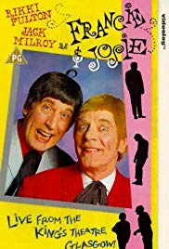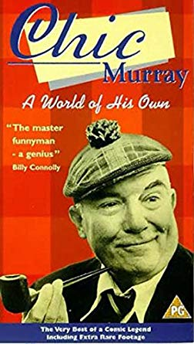

Hullawrerr
“Hullawrerr Chinas”
Do you know which famous Scottish comedy duo opened their shows with “Hullawrerr Chinas ?

If you want to, write your answer here:

Do you need a clue? If yes, there’s a photo on the next page.

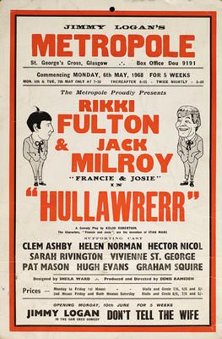

Francie and Josie were the most popular double act of the 1960’s & 1970’s

A poster advertising Hullawrerr at Jimmy Logan's Metropole in 1968. The show starred Rikki Fulton and Jack Milroy as Francie and Josie and the comedians Hector Nicol and Clem Ashby were also on the bill.
Francie and Josie were the gallus Glaswegians in Scotland's most popular double act of the 1960s and 1970s. Dressed in their sharp suits and brothel creepers, the loveable wideboys would invariably greet their audience at the start of a show with the welcome "Hulaw rerr." The slow-witted but eager-to-please Francie (Milroy) and the garrulous and self-confident Josie (Fulton) starred in their own sitcom onScottish Television, 1962-1965. The characters made several comeback appearances by popular demand, before Milroy's death in 2001.
Some newly-wed Glaswegians used to go to the Alhambra Five Past 8 Show to see the stars Francie and Josie instead of their wedding reception.
Here is a list of most popular 10 Scots words from a YouGov 2019 poll.
Read this list of words. If you have another person doing this activity with you, take turns to read them out.

- beastie – an inset or animal
- glaikit - stupid or foolish
- scunnered - disgust or strong dislike
- shoogle - shake or move from side to side
- wheesht - call for quiet or silence
- dreich - tedious; damp and wet
- bumfle – an untidy mess
- fankle - to tangle or mix-up
- outwith - outside or beyond
- braw - fine or pleasant

Now, can you guess the order of the most popular words from 1 – 10?
(Answers at the back)

Can you make up a sentence using one of the words for example,
‘It’s a dreich day.’

What’s your favourite Scots word and why?
If you are doing this activity with another person take turns each and if possible, write your answer here.

Can you think of any more Scots words? If yes, write them here.
Here is a list of Scots sayings

- ‘It’s a dreich day’ – It’s cold, damp and miserable as in weather
- ‘Haud yer wheesht’ – Be quiet
- ‘Dinnae teach yer granny to suck eggs’ – Don’t try and teach someone, something they already know.
- ‘You jist open yer mooth an’ let yer belly rumble’ - You say a lot of stupid things
- ‘Gonnae no dae that’ – Please refrain from doing that again
- ‘Yer heid’s full o’mince” – You are talking nonsense

Do you know any of these sayings? If yes, how many?

What’s your favourite Scots saying and why?
If you are doing this with another person take turns each and if possible, write your answers here.

Can you think of any other Scots sayings? If yes, write them here.

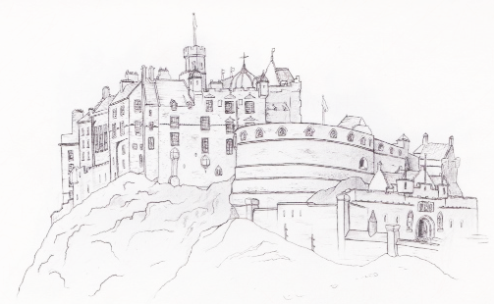

Joke fae the Poke

It time for a wee chuckle. We usually ask people to pick a joke from the bag and share it with the group. As you are in your house, we have added a few for you to read.

‘What’s the opposite of joy?’ asked a Glasgow teacher of her class.
‘Sadness, miss,’ came the reply.
‘Very good, Now what’s the opposite of happiness?’
‘Depressions, miss.’
‘Very good. Now what’s the opposite of woe?’
‘Giddy up, miss.’

Two women were talking in Princes Street.
‘Oh, hello, Mabel, and how is John?’
‘Oh did you not hear? John passed away a couple of weeks ago.’
‘I’m dreadfully sorry to hear that, Mabel, and how did it happen?’
‘Well my dear,’ explained Mabel ‘he had just gone into the garden to pull a lettuce for lunch when he collapsed with a heart attack.’
‘How dreadful for you. So what did you do?’
‘Oh, I just opened a wee tin of peas.’

A teacher asked Wee Jock, ‘If you had a pound in your right-hand trouser pocket, and three pounds in your left-hand trouser pocket, what would you have?’
Wee Jock replied, ‘Somebody else’s trousers!’

You can add your jokes here, if you want to.

We hope you have enjoyed this introduction to Scots Literacy. We want to leave everyone with a smile by reading the words or if you know it, sing-along to Sweet Violets from Francie and Josie. If you or someone you live with has access to YouTube, you can watch this performance by typing in Francie & Josie, Sweet Violets or through this link.
https://youtu.be/9vK65dPpbVs

Sweet Violets
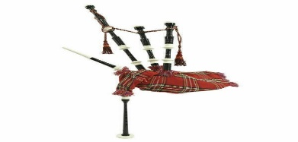
Chorus

Sweet violets, sweeter than the roses
Covered all over from head to toe
Covered all over in sweet violets

There was a young miner who worked down the pits
Who fancied a girl who had fabulous
Earrings and lived with her folks in Lochgelly
The neighbours all noticed she had a big
Garden although they were really quite poor
One of the residents called her a
Sweetheart the way she looked after her folks
Her father was minging he gave you the

Chorus

Sweet violets sweeter than the roses
Covered all over from head to toe
Covered all over in sweet violets

The farmer she worked for was quite thrilled to bits
Cos just like the miner he noticed her
Earrings and paid her to run his farmstead
The farmer was eager to get her to
Like him and put her in charge like a fool
Cos one day he found she’d been milking the
Profits and made herself really quite rich
He called her a strumpet he called her a

Chorus

Sweet violets, sweeter than the roses
Covered all over from head to toe
Covered all over in sweet violets

The next day the farmer was all teeth and smiles
Explained he got angry because he had
Problems and asked if she’d like to be kissed
The young girl refused cos she knew he was
Puggled he sacked her and caller for a taxi
She told him to shove his job right up his
Jumper because she was happy to quit
she belted him one and he fell in the

Chorus

Sweet violets, sweeter than the roses
Covered all over from head to toe
Covered all over in sweet violets

And so she returned to the boy in Lochgelly
And offered her love and her rather large
Bankbook the young miner knelt to propose
Then went out to buy her a ring for her
Finger and with it he offered his heart
She got so excited she let of a
Firework to celebrate their wedding day
From that day to this day they’ve rolled in

Chorus

Sweet violets, sweeter than the roses
Covered all over from head to toe
Covered all over in sweet violets.

Course material developed and adapted by Derek Suttie, Scots Literacy Tutor

If you would like more information about Scots Literacy Sessions or for a free pack to be sent to you please contact:

Lydia Markham, Lifelong Learning Worker (Adult Learning)
SW Locality, City of Edinburgh Council
Lydia.markham@ea.edin.sch.uk
Mobile: 07719 420 429

Please forward evaluations to me at the above email.
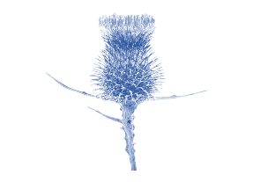

Answers to the most popular Scots words from 1 -10
- Dreich
- Glaikit
- Scunnered
- Shoogle
- Wheesht
- Fankle
- Outwith
- Braw
- Beastie
10.Bumfle

Scots Literacy P

Tell us what you think about this Introduction to Scots Literacy. Please give this sheet back to your carer/support worker or group leader when you next see them.

- Did you enjoy it? If yes, what did you like?

- If not, why not?

- Is there anything you would change?

We have lots more material we are hoping to adapt to send out. Tick whatever themes you would like more of

Cinema Dancing Fashion Industry

Education Jobs Training Songs

Games Childhood Rhymes Teachers

Sweets Food Families Sports

Music Religion Neighbours

Anything else?

Thank you for your feedback, it will help us to improve and plan future sessions. Could partner organisations please return all evaluations to Lydia.markham@ea.edin.sch.uk

