Understanding Anxiety
Session Handout

With thanks to Cathy Richards – Lead Clinician/Clinical Psychologist & Sara Shafi – Clinical Psychologist (NHS Lothian), for developing and checking the content in this workshop.

Understanding Anxiety
Anxiety is a normal response to a situation that feels threatening and is part of our flight or fight response. These situations could pose a real threat to physical safety or it could be a perceived threat. Anxiety is a helpful and adaptive part of being human in the short-term but can become distressing if the response is ‘switched on’ for too long.

Anxiety will affect people differently through our thoughts, physical sensations and our actions.

Problems arise if anxiety doesn’t go away or if it’s very intense and stops a child or adult from doing things that would be considered normal and or healthy, for example no longer being able to leave the home to collect groceries.

In these cases support is required and there are helpful strategies that can be implemented both in school and at home.

Fight, Flight or Freeze
This is a basic and ancient system that has been with humans as long as we’ve had brains. It is also known as the limbic system.

When we perceive a threat, this system prepares us to run away (flight), confront and face the threat (fight), or remain very quiet and still and hope we go unnoticed (freeze).

This system has always been with us so back when we were Neanderthals the situation might have looked like this:

You spot a tiger. Your freeze instinct kicks in – every muscle tenses, every sense is heightened and you stay hidden hoping it doesn’t see, smell or hear you.
You come face to face with a tiger. Your fight instinct kicks in – heart rate increases which sends more blood to your muscles for maximum strength and speed, hormones are released to reduce sensation in preparation for pain.
You see a tiger in the distance. Your flight instinct kicks in – you run away with similar symptoms as described above to get to safety as quickly as possible and avoid the danger.

In the 21st century it might look like this:

You’re crossing the road and a car comes round the corner at speed. Your freeze instinct kicks in – you can’t move to get out of the way.

Someone starts a fight with you. Your fight instinct kicks in – your body will prepare you to fight off the attacker.

A fire alarm goes off. Your flight instinct kicks in – your body is prepared to get you out of the building as quickly as possible.

A Guide to Anxiety for Kids: https://www.youtube.com/watch?v=FfSbWc3O_5M&t=4s

Up and Down the Worry Hill
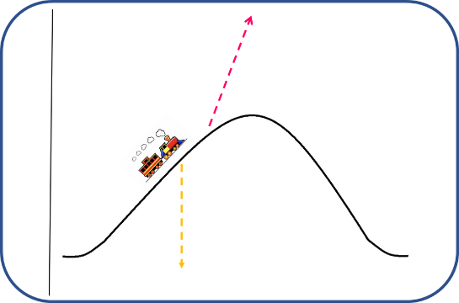

While it’s perfectly normal to run away or avoid anxiety inducing situations, research tells us that if we can face the situation our anxiety will reduce and we will learn that we can cope.

Avoidance of a situation can decrease our anxiety and we feel better in the short-term but we don’t get to learn or grow this way.

If we tackle the situation that is making us feel anxious our anxiety levels will initially go up and it will feel uncomfortable but that feeling will pass. Our confidence and self-esteem grow as we learn that all the bad things we expected to happen didn’t or if something did go wrong we were able to deal with it.

This process truly is essential for building confidence i.e., trust in ourselves.

Fears and Worries are Common
Children’s worries are often about their physical security (things like scary creatures, being hurt etc.) whereas adolescent worries are more abstract and relate to negative outcomes (things like school performance, friendship issues etc.). Around 70% of adolescents report having at least one worry per month.

Most worry is normal for the age and stage of the child’s development and doesn’t require any intervention.

It’s important that we are aware of context when we think about worry as well. It is normal to feel anxious if there is conflict at home like a separation or a transition to a new school. You will usually find that when things have settled, anxiety levels reduce.

When Anxiety Becomes a Problem
We all feel anxious for short periods of time or in certain situations but for some people anxiety takes over.

Anxiety becomes a problem when it:
- Is persistent
- Is severe
- Interferes with everyday life

When anxiety takes over you may benefit from some help.

What is Causing the Anxiety?
- Genes
- Environment
- Coping skills
- Experiences
- People’s reactions
There is no one single factor that causes anxiety but it can be useful to understand what is maintaining your anxiety as this will indicate where you can start to make changes. For example, if you have no coping strategies to manage anxiety you can take time to learn some. It is much more important to understand what is maintaining your anxiety, rather than what is causing it – i.e. what is keeping your anxiety going?

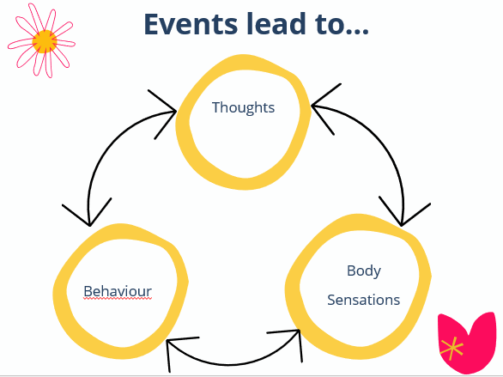

Avoidance
Avoidance is a common strategy used to manage anxiety.

In the short term:
- You feel relieved and safe
- You do not have to face your anxiety and the unpleasant feelings associated with it
- You remain in control
In the long term:
- You miss out
- You can’t overcome your anxiety
- It maintains the thought: “there’s nothing that needs to be worked on.”
Role of a Parent
The role of a parent involves:
- Supporting children to feel safe by creating rules, boundaries, consistency and predictability
- Modelling how to understand and manage emotions by naming and acknowledging the emotions your child experiences.
- Providing containment when emotions are too much
- Supporting children with facing and challenging their anxiety
- Supporting children with sleep and exercise routines

How to Help a Child Feel Safe
- Encourage independence
- Express confidence in their capabilities
- Find the balance between being warm and understanding but not being overly involved
- Allow them to learn different ways of doing things and recognize that your way may not be their way
- Calmly allow them to feel nervous with the knowledge that it will be okay for them
- Suggest coping thoughts, for example “if that doesn’t work then there are other ways to try…”

Helpful and Unhelpful Thoughts
When we are feeling worried we often have unhelpful thoughts.

These are critical and typically biased.

By challenging these unhelpful thoughts, we can change them to more helpful thoughts.

It is really common to try and offer children reassurance by saying something like “don’t be silly, you’ll be fine” but that can feel really dismissive. Acknowledge their feelings and ask them question so you can help them cope better with unhelpful thoughts.

Teach them to talk back to their unhelpful thoughts. You can also create a “worry monster” who is telling them these unhelpful things – how can we shrink it and make it go away? This helps to externalize worry and means if you get frustrated it’s with the worry monster, rather than the child.

You can help your child by asking them:
- “What would you say to a friend?” – this helps them think about how they can help themselves.
- “What would help you to feel better or what would reassure you?”
- “If the worst did happen, what would you do? How would you cope with it?” – this helps them believe they have the tools to cope.

Worry
Monsters:
- Make a sock monster
- Write down your worries
- Feed it to your sock monster
Bags:
- This is somewhere you can put your worries and read them over

Worry People
- These originate from Guatemala
- The dolls are no bigger than a match stick
- You tell them your worries and pop them under your pillow/next to your bed
- The worry people take them away for you

Exposure
As we have learned, exposure to anxiety provoking situations can help us overcome them.
If the situation feels too overwhelming to face at once, working up to it can be helpful.
Graded exposure involves gradually moving in small sequential steps from the least feared situations to the most anxiety provoking situations.

You might want to use the SMART goals framework for things like going to a sleepover, starting swimming lessons, to play upstairs in the house on my own. All of these things are specific, measurable, attainable, realistic and time focused.

You can use a ladder as a visual with the overall goal at the top and then the steps that lead to that goal as the rungs.

Top tips:
- Let your child lead and tell you what the hardest steps are.
- Start small and build on the momentum of success
- Use post it notes for flexibility when making your ladder
- Be aware that some steps may take longer to progress
- You can review steps if a ‘jump’ feels too big
- Plan ahead with rewards and make them appropriate for short, mid and long term goals
- Where possible, create situations to try steps
- Seize opportunities that arise for progress (within reason)
- Praise, praise, praise your child for trying their steps.
- Consider making your own ladder to normalise the process for your child
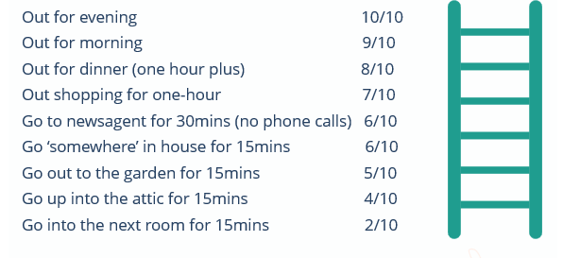
Let’s Relax
For some people the worry monsters and expose doesn’t work. Here are some other strategies to try.

The tension, stomach discomfort, aches, pains and breathing difficulties and pounding heart that are part of anxiety can be quite scary for some people. These physical symptoms can often be what people present with at the GP and they are actually a result of anxiety.

Relaxation techniques are commonly used to address the bodily symptoms of anxiety.

Practicing relaxation exercises daily helps us learn how to relax. We don’t learn new skills well under pressure so it is best to practice when we are not feeling distressed.
Once you have learned the exercises, the techniques can be used when you are feeling anxious. There are different methods out there so it is important to find out what works for you.

Progressive Muscle Relaxation
This involves tightening up the muscle groups and then letting them go – tensing then relaxing.

Deep Breathing
Drawing in a deep breath, hold for five seconds and then very slowly let it out.

Visual Imagery
Simply imagining a relaxing scene and feeling the resulting relaxation.
Review of Parent Role
- Nudge one notch above comfort zone
- Discourage avoidance and escape
- Foster self-calming skills by practicing relaxation with your child
- Create your own positive self-talk phrases
- Rewards and Praise, praise, praise!
- Label emotions, allow and create open conversations
- Avoid auto-assisting, redirect to self-assist
- Empower and foster confidence
- Problem solve
- Encourage reasonable risks
- Reflect on how your reactions may have influenced a situation
- Support sleep and exercise

Let’s Introduce Anxiety Management
LIAM is an intervention available in some schools aimed at helping children and young people learn about anxiety and coping strategies.

It is a structured approach, where a child or young person works through modules with someone in school.

LIAM referrals and progress are discussed with a CAMHS practitioner. Speak to someone at your child’s school if you think this might be helpful for them.

Resources
- Anxiety Canada: Online, self-help and evidence-based resources on anxiety
- Anxiety UK: Support and advice for those with an anxiety disorder
- Breathing Space Scotland: A free and confidential helpline for anyone experiencing low mood or depression
- Get Self Help: Education on how to manage stress (parents and 14+)
- Hands On: Provides advice for supporting children and young people’s mental health
- Mental Health Foundation: UK-based charity with advice about how to manage stress and links to podcasts (parents and 14+)
- Moodjuice: Learn more about anxiety and skills to cope with it
- NHS Choices: NHS Health Information Website about causes of stress and how to manage this (parents and 14+)
- NHS Fife Mood Café: Website produced by NHS Fife educating about stress and providing links to external resources (parents and 14+)
- Penumbra: A mental health charity working to improve mental wellbeing across Scotland
- Young Minds: National charity and champion for children and young people's mental health and wellbeing
- Young Scot Aye Feel: Information about how to look after your emotional wellbeing, support from organisations around Scotland and tips on how to promote a positive mindset

These books are available at various libraries as part of the Healthy Reading Scheme:
Blame my brain: The amazing teenage brain revealed
(2007) by Nicola Morgan
Helping your child with fears and worries: A self-help guide for parents
(2019) by Cathy Creswell and Lucy Willetts
How to stop worrying
(2009) by Frank Tallis
The anxiety survival guide for teens:
CBT skills to overcome fear, worry and panic
(2015) by Jennifer Shannon & Doug Shannon
The huge bag of worries
(2004) by Virginia Ironside
Think good, feel good: A CBT workbook for young people
(2002) by Paul Stallard
What to do when you’re scared & worried: A guide for kids
(2004) by James J. Crist
Willy and the wobbly house: A story for children who are anxious or obsessional
(2003) by Margot Sunderland

.

