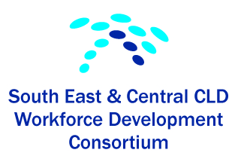

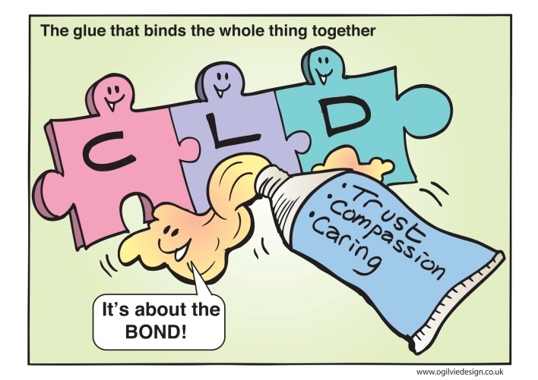
“Inspiring Confidence and Confidence to Inspire”
Evaluation Report

The South East and Central Workforce Development Consortium (Consortium) represents CLD partnerships in Edinburgh, East Lothian, Midlothian, West Lothian, Scottish Borders, Falkirk and Clackmannanshire Local Authority areas. The consortium facilitates involvement in a range of joint CPD for partners across the CLD sector.

Background
Over the past two allocations of CLD upskilling funding the South East and Central CPD Consortium has come together, formed a steering group and successfully collaborated on the delivery of a wide range of CPD opportunities. Whilst the longer term impact on staff and learners is still to be researched, to date our findings indicate that the programme of courses, events, conferences and collaborative opportunities, have been positively received and made a significant contribution to the skills and knowledge of staff and volunteers.

Application of the grant has been made “in order to continue to achieve significant learning outcomes for practitioners and managers which will have positive long term impacts for learners and communities, the focus for this second phase of the Consortium's work is to ensure a robust network that is able to:

- foster a vibrant learning environment at all levels
- support employers to encourage CLD registration for employees and volunteers
- deliver the CPD requirements of CLD Council registered staff
- encourage the use of idevelop
- play a key role in developments nationally”

Phase Two Development

The funding that has been allocated has been used to encourage and develop:

- a positive climate for sustainable continuous learning across the Consortium, where individuals can be involved in a continuous process of improvement and development
- improve uptake of CPD opportunities across partners across the CLD sector
- organise a conference bringing together practitioners, managers, academics and other leaders from the CLD field on the theme of CLD Strategic Guidance
- continue to encourage and support sharing of CPD opportunities across the consortium
- strengthen the Consortium including the steering group through administrative systems, partnership agreement, further joint planning
- encourage representation on steering group from partners including 3rd Sector, Health, Police, Colleges and Universities,

In order to develop the network's sustainability and encourage collaborative practice, the wide range of expertise across Consortium members will be drawn upon to deliver this programme. Additional input from experts at the Conference will be agreed as the event takes shape. Opportunities for input from other providers will be available through each member organisations CPD programme.

“Inspiring Confidence and Confidence to Inspire”

The culmination of the above was delivered by the consortium through a conference held on 20th of March 2014. The Conference was called “Inspiring Confidence and Confidence to Inspire”. What was envisaged was that specific input from experts in the field would encourage dialogue and through that inspire the participants in their practise.

Two guest speakers were invited with a specific brief:
Fraser Patrick retired Director of Dundee City Council’s Neighbourhood Resources and Development and who is currently a consultant in Community Learning.
- Fraser Patrick prepared a paper entitled: “Education is not neutral – and CLD?”
Sir Harry Burns who is Chief Medical Officer for Scotland where his responsibilities include aspects of public health policy and health protection.
- Prepared a presentation on Community Health.
The Conference was opened by David Bruce, Senior Education Manager (Community Services), Children and Families, CEC. Edinburgh City Council.
As an invited guest we asked Graham Ogilvie who is a Corporate Artist with a degree in Fine Art and Illustration from Duncan of Jordanstone College of Art, Scotland to illustrate the discussions with his expressive artwork.
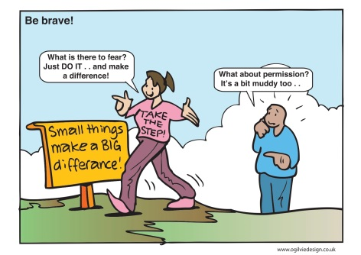
These presentations set the scene for participants to then take part in World Café Conversations around the following questions.
1. How can we make better use of the creativity and talent found in our communities…. and staff? Challenges and opportunities?
2. How do we retain and promote our values and principles in the face of current national priorities and drivers? E.G. are we now the ‘sticking plaster’ service? (diversionary and reactive activities).
3. Has the CLD worker job role changed?
4. Since 1980s the job has changed through the development of CLD as a profession instead of radical practice and challenge in response to issues identified within communities.
5. Is ‘Civic Health’ a fairy-tale or CLDs blueprint for the future?
6. How could CLD help to achieve the ‘good life’ and inspire confidence in ourselves and in our communities?
These World Café conversations were very animated and took up most of the afternoon. The feedback on the Café conversations was positive and the comments written up as part of the feedback to participants. These notes have now been circulated to the consortium and the participants. (See Appendix 1)
Evaluation comments were collected and comments and inspirational messages for the consortium were also collated. These will be circulated to participants. These have also been very positive. (See Appendix 2)
Participants were also asked to decide which twelve of the messages portrayed in the art work around the conference were the most important. (See Appendix 3). These twelve will be circulated to the participants for their use to inspire their practice.
Overall the evaluations were very positive and many comments were indeed about being inspired. These evaluations would be considered to endorse the consortium’s view that the conference was very successful and achieved their outcome.
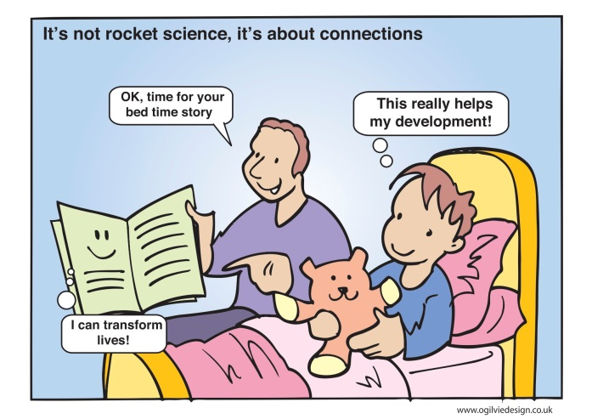
In view of the current difficulties facing CLD services across the consortium i.e. staffing reductions, restructuring and general funding difficulties, the consortium felt that having this conference was an important way to support isolated and demoralised staff. By inviting them to come together to discuss practice, share ideas and feelings about the way forward, participants gained peer support and shared ideas and ways to solve present day issues. The consortium also felt that this should not be a ‘one off’ event. Throughout the life of the consortium there have been comments made about the importance of peer support, working across boundaries, sharing good practice and the development of CLD. The consortium have been active in creating opportunities for CLD practitioners to be involved and felt that the next step in providing further opportunities was to programme another conference ‘Inspiring Practice’.
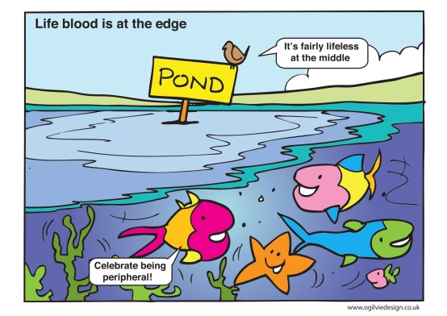

“Inspiring Practice”
A conference to discuss the dilemma of practice in a ‘safe harbour’
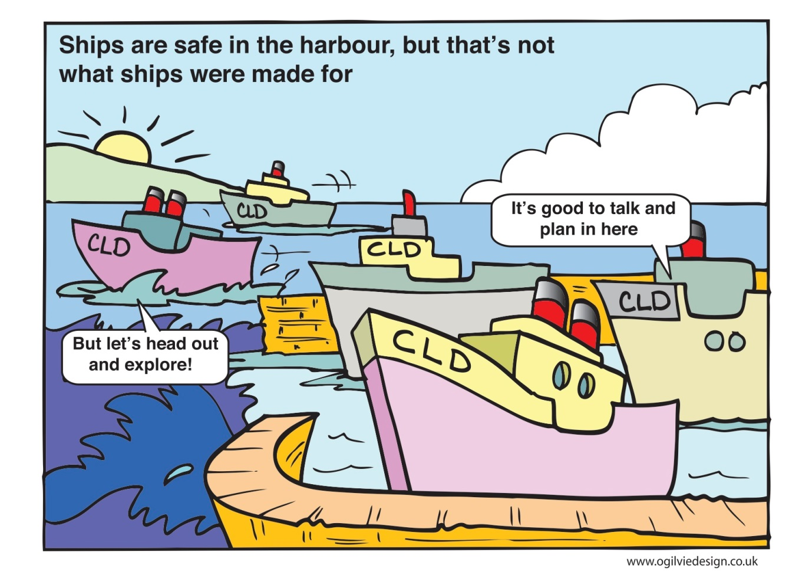

As further staff development it was agreed by the consortium to encourage all the participants to attend a second (follow-up) conference which is entitled “Inspiring Practice – A conference to discuss the dilemma of practice in a ‘safe harbour’”. This conference will be delivered using an innovative technique called Open Space Technology where the participants get the opportunity to discuss any issues, dilemmas, barriers or blockers in a safe and confidential environment. This conference will be held on 29th of May 2014. The discussions will be led by practitioners who originally were trained by CLD in Falkirk Council (Open Space Technology - Training the Trainers) who provided the opportunity to members of the consortium or practitioners within CLD using funding from Education Scotland to subsidise their training. They will be given a refresher briefing on the evening prior to the conference and they will then lead the discussions using the OST techniques on the day.
Further evaluation of this conference will be provided at a later date. (Appendix 4).
ALL of the papers, presentation and Appendices will be uploaded on to idevelop for open access by CLD practitioners.
Appendix 1
Feedback from World Café Conversations

“Inspiring Confidence
Confidence to Inspire”

A Conference for CLD Practitioners and Partners

Thursday 20th March

World Café Conversations

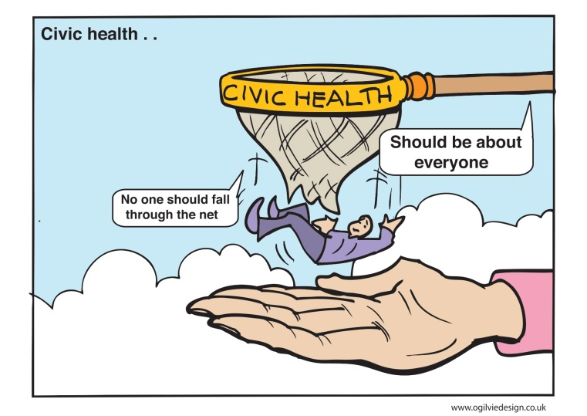
Tables 1 and 2
“How can we make better use of the creativity and talent found in our communities … and staff?
- Challenges and opportunities?
Table 1

Discussion points:

- Having a voice for CLD
- Putting up barriers to creativity – expectations
- Policy constraints – who challenges this
- Working with partners – (no one agency/agenda) to create space to be able to be more creative.
- Better use of creativity
- Endorse open communications
- Time out every week/fortnight CUY tea and chat – Idea time
- Publish great ideas web/film YouTube 2 minutes.
- Think! Think! Think!
- Positive mind set – find one “glass half full” people and work together
- Harness local talent – support people to set up groups, find venues, recruit
- Managers – non CLD. Not understanding or respecting CLD Prof
- By valuing ideas from community members, supporting them to make them a reality and celebrating success to encourage more.
- As a workforce we are Not enabled to express our creativity as CLD workers/with people in local communities – we are operating in a ‘straight jacket’ realist culture
- PRD restrict practice
- Reality?
- Is it about completing tasks?
- Space to think?
- Opps. Safe Harbour a ‘learning culture’
- Finding like-minded people to talk to and work with
- Policy shouldn’t restrict or put young people on surveillance, rather focus on what they want to do.

Creativity in CLD
Two Key Points Creativity
- We want to do it together (play and be adventurous)
- Challenge is to embed a culture with management (whoever is managing) – belief/trust in staff and people in communities. There is creativity and talent.
Discussion points
- There is talent in the community – all ages
  - How do we make the connection and engage these people?
  - Community members and staff

- Creativity in team working? Focus is a wide individual planning from management
- Creativity / making mistakes is not encouraged in CLD with LA
- No space/encouraged to link theory to practice – retract. Management do not value at this?
- Context from management – driven by preset outcomes- stifles creativity. Funding and Numbers
- People can surprise us – do we limit them?
- E. Lothian framework at outcomes does give a space within which to be creative.
- HMIE focus creativity in inspections would help drive improvement in team creativity and harness communicates creativity.
- Policy: should be driven from what young people want and need
- Curriculum ha narrowed into core skills, employability
- Ticking boxes
- Lack of joined up planning from senior managers
- Community – We do it already but we need to be better at it harness in creativity sometimes we limit (range of opinion)
- Staff – feeling construed (policy finding management) “Straight Jacket”
- Build and value team CLD – Values and principles. Not ok to make mistakes/ ok to take risks
- CLD – can always find space to be creative, but it is difficult. More opportunities in 3rd sector? Still autonomy for practitioners. Use new technology. And ideas. Difficult in structures where CLD values not embedded
- Consortium role – safe harbour. Managers need to support staff to have creative spaces such as this. Find solutions and support eg justifying impact at IT courses.

* We need to be better at challenging. The context is given and some things we can’t change. It forces us to be Creative.*
Table 2
Summary
- Collective Creativity
- Space
- Challenge
- Culture what works
- Showcase – promote
- Assets – are we?
- Strengthen individuals/team/community

- We have to creative (At this stage in local authority process) to maintain our values principles and practice
- Management needs to create the context of release of creativity in staff.
  - Trust
  - Respect
  - Belief in “Humanness at the centre”

- What do we value in our society?
- Not everything that can be counted counts and not everything that counts can be counted
- We are not creative enough at promoting ourselves
- The “SO WHAT” question. (is it acc
- Our creativity is being channelled in to survival!
- We are currently losing the battle for our communities and profession!
- “Finding the spaces the people”
- Relationships
- Trust – context
- Creativity: yes restrictions came into mind

- Coffee Time = time to come up with new ideas
- Creativity difficult in school setting
- A coffee with someone!
- CPD Value and principles ‘hold on’
- Safe Harbour
- Go off programme
- Allow ourselves the time to start conversation
- Prescriptive funding.. Target and view
- Enabling opportunities
- Off the hamster wheel -> into safe harbour -> create the space for dialogue. More D+D among CLD workers

Tables 3 and 4
“How do we retain and promote our values and principles in the face of current national priorities and drivers?”
- E.g. are we now the “sticking plaster” service? (diversionary and reactive activities)
Tables 3 and 4
How do we retain and promote our values and principles in the face of current national priorities and drivers?
Discussion points
Table 3
Priorities and drivers
- Paternalism
- Economic drivers – Employability
- Targets adn numbers – meaning we can be less reactive
- HMiE driven practice
- Accreditation
- Professionalization
- Big ‘P’ partnerships
Retaining and promoting values and principles
- We’ve still got our values and principles – but do we/can we promote/use them in our everyday work
- Being part of a Community of practice helps us retain them - Able to know you share values and have opportunities to get support from others
- In school setting it is all about retaining and fighting the CLD corner.
- We have the passion and commitment to ‘find the spaces’
- We have our values – and we enact them, can articulate them (mostly) but are people listening and are they understood
- Building relationships across settings where CLD values don’t apply to get engagement with the people we want to work with – easy to get pulled into other agendas.
- When we explain CLD to others, are they actually listening?
- Need to keep reinforcing the difference in how we apply the values - Clarity of what we do/the why and the how – eg that participating is voluntary etc
- Need to increase turnover of staff – but not necessarily the magic solution
- We need opportunities to re-visit our values and principles!
- It’s something I hear again and again at these kind of events – this is great time to reflect, time to reflect on the fact that our radical nature has not disappeared but how we hang on to this in the workplace – how do we do that how can we be helped to do that?
Professionalisation
- Is this strengthening our position?
- But is it limiting entry points – excluding
- CLD Standards Council - Maturing the profession – but maybe still early in the process of forming, norming then performing
- Need to be ‘professional’ vs ‘professionalisation
- Role of the Standards Council is crucial to informing the values and principles of CLD with employers and policy makers to ensure they all understand at national level. Also important in positioning the CLD profession – important to maintain their identity.
- CLD regulations strengthen our position

Sticking plaster service?
- Perhaps we are a ‘critical’ service, much needed now that as a country we have to make important decisions.
- Always been a ‘sticking plaster’ service - as an organisation vs individual values and principles
- But there is a vulnerability to CLD when performance management is the focus

Are our values and principles that unique?
- Professionalism – is also a driver but are we that unique – by emphasising our difference are we creating silos
- Breaking our own silo – inclusive of others working in a CLD way with same/similar values and principles but don’t define as CLD
- Values & principles – converging across range of contexts and professions - What makes CLD unique is how these translate through process and become meaningful
- Our uniqueness is not necessarily our values but actually our processes and product
- We need to develop a better understanding of the values etc of key other professions and do this with them – need to improve training across the wider CLD sector – people working in a CLD approach – or those expected to..........
- Training (initial/CPD)
- Cross-over
- Joint training
- Values and principles do make us unique – because the answer to the question of HOW=YES
Table 4
(e.g. are we now the “sticking plaster” service? (diversionary and reactive activities)
- Status never higher i.e. legislatively with CLD Regulations and Community Empowerment Bill –how do we use this opportunity to strengthen our service? Not a view shared by all that our status is never higher.
- Position builds confidence at national level. Interesting dilemma between national and local level.
- At local level – authorities are shaky, uncertainty, low morale, changes sap energy. Staff finding ways to console themselves by using i-develop, for example.
- We are agents of social change.
- The best of times, the worst of times

- The notion that many other services and departments are delivering community learning & development but not necessarily by CLDS. Have other services jumped on the band wagon, do they fully understand the community development approach?
- Community learning & development a service or an approach?
- CLD methodology bleeding into other services – engagement / empowerment.

- Are our values under attack?
- Staff trying to embed CLD in an organisation, leaving a legacy. No matter what you throw at me I still have my values – you can’t take that away from me.
- Are we Health & Equality driven?
- How do we affect the policy we are in?

- What are our CLDS priorities? Are we everything to everyone and viewed as the sticking plaster?
- How have our values and principles fared in the face of cuts and restructuring – how has this affected our focus?
- Create political support to protect our generic service, able to retain our values – Falkirk.

- CLDS lower in numbers of staff, influence, not acknowledged – unless employability. Recruitment – now not a requirement to have CLD qualification for 1 local authority. Differences in structures and where CLDS fits within this or is broken up/ qualification requirements across different local authorities vary e.g. West Lothian v East Lothian.
- Registration – does registration matter, what are the benefits? Is it an endorsement? Some staff feel it is important to be registered as it gives them the support to say they are registered and confirm their values and principles.
- Our biggest challenge is working in schools – debate around targeted versus universal provision / GIRFEC.
- Conflict – do we go from where young people are at i.e. their agenda or are we deciding their agenda for them?
- Young apprenticeships – how many offer real opportunities?

- No space for debate – critical voices are quashed. Inspection driven. Buzzwords – employability. Not debating our priorities but driven by other people’s agenda.
- No voice – failing of our sector. No professional voice. No choice – bulldozed.

- We are creative and find other ways round issues, that is our strength. Do we go underground become more subversive, is this comfortable position to be in or should we be more transparent?
- Do we need a harbour for reconstruction and deconstruction?
- Need courage / strength and re-assurance to keep going.
- Lead by example – be mindful.

- Referendum – big date in Sept – where next?
Tables 5 and 6
“Has the CLD worker job role changed?”
- E.g. are we now the “sticking plaster” service? (diversionary and reactive activities)
- Are the challenges and opportunities still the same?

Tables 5
Since 1980s the job has changed through the development of CLD as a profession instead of radical practice and challenge in response to issues identified within communities
Professionalisation has its good points:
- Greater value accorded to CLD through multi-agency work eg schools
- Still able to deliver adult learning, youth and children’s work not too dissimilarly from before

... and its negative points:
- University CLD training courses are driven too much by academic qualifications when identifying recruitment to courses, rather than motivation of applicants and their personal qualities. Radicals are kept out of courses
- There has been a ‘silencing’ of CLD as part of the Council structure. There used to be ‘activism’ within community education job descriptions. Capacity-building has suffered hugely from the incorporation of CLD firmly into the bureaucracy
- Profession is driven by inspection , value for money and impact and ‘good practice’ measures. Curriculum has narrowed to meet Scottish government priorities
- We try and hook ourselves in to everything and can’t meet expectations within a multi-agency agenda. Not clear enough about our own identity any more

With the new agenda of Strategic Guidance there are huge assumptions made on our ability to meet these challenges. Upskilling is an important part of the solution
Colleges need to be better at recruiting to university CLD courses, it shouldn’t all be about qualifications
Changes have happened over the years in the balance between generic and specialist posts but there is no consensus on this. Generic practice can be deskilling.
Workers push more paper in common with other professions .
Multi-agency work can be very positive when it works but it can mean other people taking over CLD work .
There is still freedom to find the gaps in which to do creative/radical work but this work rarely challenges the local authority
Issues are still the same eg youth unemployment and we still deal with this creatively .
Society has changed and young people tend to go on line to ‘rebel’ rather than campaign so it can seem less powerful. Definitions of community have changed and resistance is much less visible than previously
We are an ageing profession now. We need young people to enter the workforce who reflect culture and society as it is today
Table 6
Group One
- CLD departments are splitting up
- Capacity building being merged with community planning as part of education department
- Emphasis on ‘positive destinations’ – specialist education & youth work
- Adult learning being part of an ‘employability hub’
- ALN / ESOL / Adult Learning merged into ‘employability’
- Having to use terms like ‘business models’
- Big emphasis on ‘positive destinations’ and modern apprenticeships
- The job is turning into glorified employment trainer
- Little chance to stop, think, discuss, plan or meet for the sake of meeting
- SSI Strategic Guidance contradicts reality
- CLD becoming more of a theoretical idea than a physical department
- Not enough new people coming through the ranks due to cutbacks
- CLD workers being sucked into schools to ‘control’ difficult kids who would normally be sent to special schools

Group Two
- CLD departments looking like splitting up
- Increased involvement with job recruitment administration (formally HR role)
- Doing more and more administrative tasks
- Stuck in the office more and more
- Public engagement reducing
- Increasingly involved with ‘problem’ kids in schools
- No thinking space
- The chance of follow-up projects are being reduced
- Increasingly pulled towards priorities, which are not necessarily CLD priorities; e.g. Employability
- In Edinburgh each High School has a CLD worker attached
- Lots more ‘impact’ planning & must have reference to Curriculum to Excellence
- More balance is needed between formal & informal learning
- If moving to a new department – do you work in their style or your own? CLD ‘style’ of working can be diluted or lost when moving to new directorate. Will CLD lose its values and principles?
- CLD’s protective shield from higher management can be removed if higher management is not knowledgeable or a believer in CLD
- CLD ‘culture’ being lost
- Now working as a ‘CLD approach’ rather than a CLD service
- Because of increasing school based work it is a lot more formal. School security issues are killing the informal ‘drop-in’ element of traditional CLD.

Group Three
- Community education is now about box-ticking and outcomes
- CLD is becoming centralised – the Government is telling CLD what it is, not the workers
- There are radical job changes
- People who started as community activists see that role as little more than ‘lip service’
- CLD workers are now an arm of the establishment
- We are victims of the Government agenda
- The CLD profession is becoming professionalised – e.g. qualifications based
- CLD services being decimated
- With CLD services being dismantled, we are losing our focus
- In who’s interests are we serving?
- We are accepting of the ‘corporatisation’ of CLD – we don’t have to
- We have the opportunity to influence CLD strategies and plans
- We can (and should) change ourselves
- Lots of academia involved in CLD
- Legislation could remove the professional element and self-autonomy of CLD and CLD workers
- We have adopted the language of business: ‘outcomes’, ‘outputs’ and ‘targets’
- We are increasingly having a Civil Service Culture
- We need to re-find the ‘activist’ element
- Professionalism may make us more ‘elitist’

Tables 7 and 8
“Is ‘Civic Health’ a fairy-tale or CLD’s blueprint for the future?”
- What is the role and contribution of CLD and partners?

Table 7
Group 1
- Is there a culture of Community Conversations and Exclusivity? Do we use the information out there (i.e.Escobar) to actually change our practice?
- Create an open culture of community conversations.
- Nurture of the individual – We can make a difference if we work from the bottom up.

Comments
- Not a fairy tale – based in reality
- Yes it is a fairy tale BUT we need a vision
- Too Utopian
- Principle is fine but not got the capacity
- Neither. Neither- Did Robert Owen change the world?
- Can we change our world?
- A Blueprint for the future – but how do we get there - crucially challenging the powerful.
Group 2
- Reality Check needed of how civic health fits in with real life. Can’t get people to engage. Could Civic Health be what we aspire to?
- People have such “shitty” lives that they can’t take part or be involved. Getting them involved is a major achievement. Take little steps (but not too much). Work from the bottom up.
- People are disenfranchised it is difficult to get them involved. We don’t take people on marches to demonstrate any more. We get questioned about our actions – even in our own time.

Comments
- Who is protecting and developing our democracy?
- Are we ‘tampering’ at the edges or working at the core?
- Civic Health – Top Down? Relies on the say so of local power brokers.
- How can we create cultured creative spaces where ‘Everyone’ can be involved?
- Huge levels of inequality – How does Civic Health address this?
- CLD contributes to many aspects of civic health but it can only contribute to a relatively limited level.
Group 3
- A wish with no change or blueprint for the future to challenge the future.
- Are we community activists anymore? Are we more career based rather than vocation based – where has the ‘fire in your belly’ gone?
- How does the school system ‘supress’ the young people to make them ‘conform’ to reach positive destinations.
- The Community Learning Plan of 2015 – We must have a say in how that develops.
Comments
- Contradiction – Reflective service where is that opportunity?
- How do we use the skills and influence that we have best to move towards a ‘better’ future?
- Structures make the change difficult
- CLD workshop skills – use outside the neighbourhood structures
- You can’t have a map for the future but you can have a compass to show the direction.
Table 8
Group 1
- Things need to change.
- Mindfulness has a role to play in moving change.
- Decision Tree – use of this can help in change.
- Believe in people, community and passion for both.
- Positiveness MUST come across in language used.
- Civic Health – good on paper – could be used – but what about ‘reluctants’ or ‘naysayers‘or ‘scapegoats’ or those left behind (e.g. drug addicts)? Repercussions of not having everyone on board?
- Finding allies is key – can be exhausting, but is worth it – less exhausting than doing things on your own.
- Look to Europe – Scandinavian countries, Germany (reunification challenges) – where things work – replicate them.
- Don’t think there is enough dialogue/space for genuine dialogue. How do we develop this in our practice when it is hard for us to do this with each other?
Group 2
- Another title/idea – where does this sit in in the current context of increased prioritisation of and undermining of public services and the health sector?
- Opportunities for dialogue at work? The ideas people come up with can be built into future plans.
- Relationship between civic health and public health needs more thinking & critique.
- Some good practice with staff in Falkirk – acknowledge wish to shift more to dialogue from discussion.
- Bringing key partners together is important to have genuine dialogue and action.
- Blueprint for ‘good society’ NOT just CLD practice. CLD contributes but not able to shift things alone.
- Dialogue – what stops it?
  - Barriers are structures
  - Who invites who to partnerships, why, on what basis?? (CPP’s)
  - Fear
  - Civic health may provide a structured approach to delivering more effective dialogue.
  - Control – taking control or “giving it away” (applies to practitioners and politicians).
  - People disengage when not being ‘listened to’.
Group 3
- Not a fairy tale if taken as a concept (aspiration) to move toward – be different if it was imposed (not happen).
- Civic Health – idea to move away from’ medical health’ – current risk of CLD being pulled more and more into medical health agendas.
- Map and acknowledge skills and values of all contributing to dialogue or any civic health model.
- Frameworks such as ‘Early intervention’, GIRFEC, preventative/upstream intervention - are imposed and can be barriers.
- CLD can contribute to part of civic health aspiration.
- Civic health can be integrated in current plans & structures (as a road map of where we want to get to).
- Civic health about cooperation and working together (Professionals, practitioners, agencies, participants, public & private) – need to sort out ‘healthy working’ from partners/ practitioners & agencies to share values and ensure ‘dialogue/engagement is sincere and will work.

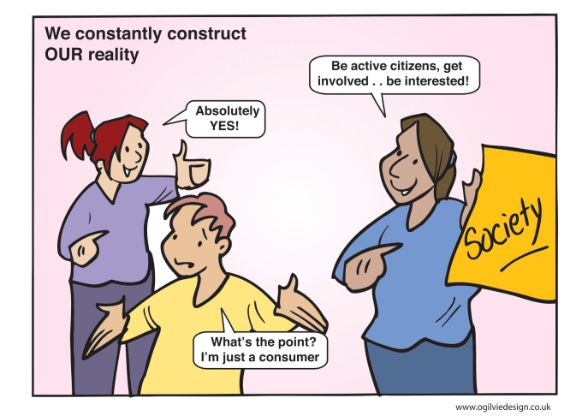
Appendix 2
Evaluation Comments
This event gave a real insight into the issues and concerns of CLD workers and where they are placed in local authorities. There was lots of opportunity for discussion, issues and challenges faced in local authorities are mirrored/echoed in other places. The speakers were informative and made a valiant effort to inspire confidence. The graphic illustrations really helped to remind me of the key points raised throughout the day. I will take away with me a real understanding of the issues facing the field. Environment and organisation were fine.
Content: V relevant and inspiring. Would have preferred to have continued Question & Answer with Sir Harry Burns so we could have been sharing as a whole. Personal Experience: Motivation needed to keep going but to also reassess work practice and who is setting the priorities. Environment: Well planned and co-ordinated. Great venue.

I thoroughly enjoyed todays’ event it was both inspiring and confidence building. The presentations were both relevant and thought provoking. This conference has helped me to understand better the role of CLD of ways in which I could work better in partnership with them. It would be good to see more partners round the table to reflect the ‘ learning communities’ of the range of partners practising CLD. Excellent to see Health included and consideration of the contribution (increased) that CLD could/do make. Excellent venue and lunch & treats. Overall – very good. Thanks very much for my place and organisation .
The day was well structured and both speakers were inspirational. The graphic illustrations were a great way of pulling the content together. I felt that the inputs reconnected me with my roots and validated the reasons that I came into Comm. Ed. I will stay with my values – I would want to meet with colleagues more often. The Venue was excellent, coordination smooth and food excellent.
Content: Excellent input- Fraser e.g. books, case studies, challenge. Also Harry Burns – inspirational to challenge assumptions. Personal: I’m from a partner – thank you – third sector can find CLD very receptive to new ideas, more than other statutory partners.
Challenging and informative. Will look at new ways of gathering data. Felt that I know what I should be doing and how I should be doing it reasonably well already – frustrated that the ability to take things forward is often blocked by external constraints and the need to ‘box tick’. Excellent venue and refreshments – well organised event.
Excellent speakers – inspirational, informative and enjoyable. Good mix of input and discussion. Good space to talk and discuss and network with staff and students from other local authorities and third sector. Venue – central, close to station – good choice.
Excellent speakers – inspirational in the sense the day afforded CLD issues from a ‘different’ perspective. Important to act on the spur of “what needs to be done”. Good venue and organisation.
Content: I found the day highly relevant to my practise, well structured and paced, with adequate time for the café conversations and some much appreciated inspirational messages. Personal Experience: To include more “hands on” in my practise, using the skills I have. Using resources to better effect, scientific data in support of developments/projects. Environment and organisation – All Excellent. Thank you.
Venue OK, lunch excellent. Co-ordination has been very good. Content – the presentations were fantastic, very thought provoking and grounding. My own paid employment is slightly tangential to CLD that I have several ideas from today for my work. I have made a number of useful contacts, re-connected with contacts from before and generally enjoyed being with like minded people. ‘Bad’ practice – could be used for action learning sets?
Today has focused me back to the grass roots of the work of Community Learning and Development. The structure and pace was great and the venue very suitable.
Everything Good – structured well and relevant to practice. Graphic illustration Excellent, Good idea and excellent input from Harry Burns . Lot of similar thinking, lot of similar difficulties. Venue and environment excellent. Thanks to all involved in the day.
Content of day was very relevant to my work. Both speakers inspirational. More confidence to get information out to groups, particularly early learning issues. Hotel very nice. Liked layout – one problem was amount of stairs one room to next.
A really inspirational day. Very interesting speakers, thought provoking conversations. I will go back and think about how I am going to challenge (myself and others) and to continue to enjoy what I do. A day very well spent – thank you. Good venue, lunch and refreshments (+ nibbles!).
Very nice venue, comfortable and we were well provided for. Structure worked well. I really enjoyed the inspirational speakers. As a student I have appreciated the opportunity to attend the conference and meet lots of different practitioners and hear stories from the “shop floor” practitioners. Informative and valuable day.
The venue was ideal on good transport routes and discouraging use of car. Facilities were good. Fraser Patricks present should be made to the “decision makes” at both Council and Government level. In terms of practice it allows the sharing of ideas and practice and this is a definite benefit. It would be good to see an increasingly important holistic approach as set out by Fraser – it is inspirational, aspirational and inclusive!
Great chance to spend time to reflect and think, hear some inspirational speakers and listen to some ideas around the café spot – it’s a shame that events like this are the only space it happens as work places and other spaces should also encourage dialogue.
Structure well, venue, food , visual images, resources very good. Enjoyed speakers – useful to lay out the social context that impacts on wellness and the role of community development in promoting wellness. Valued informal discussion.
So glad I protected time in my workload to attend. Absolutely made all the connections, which were becoming a bit foggy, of why I trained and qualified in CLD. My challenging self is coming to the fore, absolutely, it’s about the people we work with, in my case, young folk, I need to support them - and me - to feel the fear and do it anyway in my practice. Structure of day, speakers, facilitators allowed a very smoothly run event. Everything in environment was fab & organisation of event was obviously well prepared and executed. Thank you. Loved the graphic illustrations.
Two excellent speakers and graphic support extremely helpful. Useful to have safe space to reflect on ideas; focus on ‘driving change with data’ and feeling supported in the work we do (but challenged). Welcoming and friendly accommodation.
Content: Having the time and space to reflect is paramount. Speakers were indeed inspirational. – Graphic recorder etc. – facilitation etc. – all fine. Personal – Just do it. Take risks – go with instincts/gut feelings. Environment – fine/no problems/good.
The whole day has been interesting as it has given me a lot of thought as to why I became a CLD worker. Definitely will try to recapture the meaning of CLD. Venue, food, layout – excellent.
A fine balance of delivery of information and participation. Acknowledge the positive work by partners in the local and wider communities. Forum for partners to attend, NHS, LA, Education, Third Sector, INTERFAC’S, collectively changes one being made to help deliver services and make a healthier society. Keep believing in a society of wellness.
Inspirational women speakers next time please and let the men … and explain activities. Great opportunity to reflect on practice and recharge batteries & feel inspired and motivated. Nice venue, near train station, great food.
I always look forward to these types of events to have the chance to talk to like-minded people – or at least we assume we are like –minded. Sometimes it’s great to actually have time to tease that out in a ‘safe harbour’ – we need more time in the harbour.
Inspiring confidence – great speakers – would like to have woman speaker – greater balance. Good to catch up with colleagues outwith my local authority. Bad practice – Action Learning Sets. Good venue. Graphic illustrations good to re-inspire learning gained today.
As the TSI we work very closely with our local CLD team but it was fantastic today to get the opportunity to meet and learn from practitioners in other areas. A very positive day.
Excellent speakers/content and space to debate the essence of what CLD should focus on. Much needed “safe harbour” to get to grips with opportunities/constraints and space to reflect on the best way forward for CLD and the people and communities we work with – towards achieving real benefits for local children/young people/adult learners and communities. Thank you Enjoyed today and all the inputs from the speakers. Thanks also inspirational – Graham – Fab graphic artist!
Content: very relevant – Fraser Patrick article great. I gained ideas for planning work which could be delivered more challenging, critical way and the confidence to make time and encourage staff in the project to take time to reflect and plan together.
Very glad I made the time to attend. Good central venue, service and lunch. Excellent speakers who made me think and ood participative sessions. Looking forward to follow up event on 29th May. Will make a fuller report of learning after having reflected on today’s event and will provide in May.
The benefit of bringing ‘CLD’ staff from across council areas was obvious throughout the day. It reminded us of why we do what we do and that we have some responsibility for, and opportunity to, re-influence and shape CLD’s future. Let’s find our voice, sense of purpose, the values we own and act on this. Feedback share was reasonably similar so points a way ahead.
Achieved objective “Inspirational” both for my practice and professional self. As always enjoyed dialogue of colleagues and “gid to see folk”.
A hugely inspiring, supportive day. Excellent speakers etc. Reconnected to CLD and hope to do more joint working. I really enjoy working with CLD because they are prepared to think outside the box. I will definitely look at idevelop.
Fraser and Harrys input were very interesting and thought provoking. The café chat was also useful in terms of hearing from others and sharing practise/thoughts. The venue was great, comfortable and good food/coffees. I will attempt to visit other areas to learn from further afield colleagues.
The conference was energising, 2 good speakers and the workshops discussions were affirming of the value of our work, that independence of continuity to do what we do and believing that even small things can make a difference. Important to keep people connected with others from different authorities and sectors. Illustrating was excellent. Work Café worked well.
Great to work with others to look at the work we do – and look at how we may work differently. Information from Fraser Patrick and Harry Burns was great and need to think about how we can get health and other information to inform the work we do.
A really lovely affirming atmosphere – collegiate a discussion with my peers. Stimulating and inspiring inputs with the whole think captured in pictures. I’ll take information back to Standards Council. Organisation/venue very good. It’s given me some ideas for CLD’s Learning Culture to strengthen and develop this. This event is a great example of learning culture.
This conference has been a) confirming (CLD values still exists) and b) informing (current practice), c) inspiring (speakers). It was good to work together have discussion and debate. A lot of “moaning” going on in discussions but this is important time to look at solutions/ways forward would be good – maybe pledges of action to take away.
Each element of the conference worked extremely well. The presentations and discussion were very valuable. I enjoyed meeting so many passionate CLD practitioners. Enjoyed sharing practice and developing vision. The setting was fantastic. It’s clear how much people value the opportunity to critically reflect.
Exploring the value base of CLD delivered by Fraser Patrick and the focus on ‘alienation’ by Sir Burns gave much food for thought. In relation to my/our practice. It has reinforced the need for ‘adventurous’ practice. I*t’s essential that CVLD practitioners are given the opportunity to reflect on their practice in platforms like this. The venue etc. was very good.
Content: Excellent. Everything – start using real community work again. Environment and organisation very good. Evidence gathering and robust research are essential to delivery. Action that makes a difference – will do much more of this. Great opportunity to revisit why we are here (to help each other to make things better!)
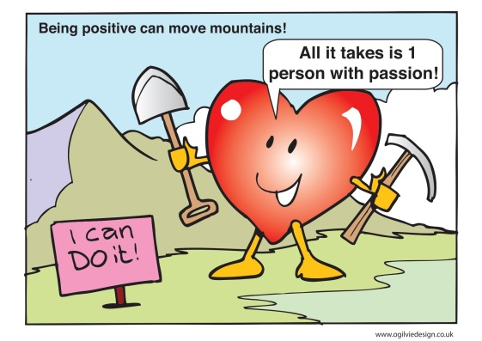
Appendix 3
INSPIRATIONAL MESSAGES FOR OURSELVES AND THE CONSORTIUM FROM CONFERENCE 20 MARCH 2014
Inspirational Messages from all participants
Inspiration
- We can and do make a difference
- Reminder you have the skills etc to do what we do
- Reclaim social group work
- Permission – get out there and do it
- Relationships – uniqueness of CLD
- Trust
Consortium
- Scope to link up with health – public and incorporate into 3 year plan CLD Regulation – what we are doing and not doing
- Networking – share innovations within CLD
- CLD discussion – what this means – wider than the Service and more inclusive of partners e.g. Invite more Community Organisations and develop links
- Highlight issue based work in schools
Inspiration
- Nurturing ourselves, sharing with like-minded people
- We need to do less and protect time for reflection and planning and therefore may need to do less of other things
- So do we need to prioritise work?
Consortium
- Continue to offer space to reflect
- It’s good to talk.....better to reflect ...... best to act
- Need to be quality driven not task focussed
Inspiration
- Risk taking
- Underpinning research*
- Saying No
- Shifting resources
- Clarity about our role
- Multi-Agency Training
- Partnership Agreements
- Knowledge is Power! * (newsletter from Harry Burns!)
- I Develop
- Inspirational conversations
- Cross Border Action
- Learning sets “What’s gone wrong”
- Field Trips inspirational practice
- “Ideas”
- Need to get out more!
- Invite people in!
- Insular workers – encouraged to get out, seek ideas outwith. Embed in practice
- Have a coffee with someone – start the conversations
- Inspirational Managers
- Systems world – Managers must change!
- Interdependence
- Engage people, SMARTER about sharing with others
- More get togethers
Inspiration
- Aim higher, look lower
- Just try it! – there are dangers, protect yourself
- Protected reflection time
- Unintentional outcomes can these be of greater significance
- Fraser Patrick and Harry Burns – presentation to ministers and senior councillors ...
- Sharing innovative practice
Inspiration
- Break it down into small bits that are do-able
- Let’s all work in early years and do something for the next generation
- The fact that this conference happened is inspiring. (If you feel isolated then you can’t work so effectively) Sharing info and ideas
- Careful about the media messages – they don’t help our cause and may not be true
- Build an educational bridge between CLD and Secondary Schools: starting this partnership with collaboration between Teacher Training and Community Education at University level: - from the bottom up.
- Engage with the values of people and their lives
- “Be an activist so encourage activism”
Inspiration
- Break it down into small bits that are “do-able”
- Let’s all work in early years and do something for the next generation
- The fact that this conference happened is inspiring. (if you feel isolated then you are not as effective)
- Sharing information and ideas as well as working in partnership is vital.
- Careful about believing all the media messages.
- Question – What about equity of access for everyone?
- If it works do it again two or three times. Find a good way to work: SHARE IT – TRY IT - USE IT AGAIN.
- Use local resources (people etc.) for the benefit of the community

Consortium

- Keep the connection with the field
- Consortium should act as a facilitator i.e. idevelop, other conferences, discussions
- There is a college network called ‘Dangerous ideas’. Could the consortium do something similar - out of the box ideas to help with working inside the box.
Inspiration
- Things need to change.
- Where there’s a will there’s a way.
- Find a way NOT an excuse.
- Just do it!
Consortium

- Get others (from wider CLD sector & contributors to CLD involved) e.g. NHS practitioners.
- Daily hugs.
- Create and sustain space for OUR (CLD) dialogue.
Inspiration
- Data is powerful. Use it intelligently.
  - Evidence of impact
  - Improve practice

- CLD practitioners are skilled at doing face to face work – this brings value to work and motivates practitioners
- Consortium as a collective voice is powerful
  - Can it develop it’s role beyond work force development to include acting as a voice for CLD practitioners – what is the standards Council role here?
    - Support for CLD strategic Plans. Practitioners want to be involved and to have some ownership of the process.

- Feel back in touch with CLD practice. Know I can make a difference and support change; take some responsibility individually and collectively.

Consortium
- Using data wisely and powerfully. Sharing practice on this – eg Ian Boardman research on value at youth work in Europe
  - What does it tell us and how can we use this?

- Developing a Voice – connecting to other CLD practitioners
- Challenges around developing area partnerships for CLD Strategic Guidance implementation
  - Who (partners) are involved
  - How do people have a meaningful voice
  - Building collaborative models
  - Workforce development
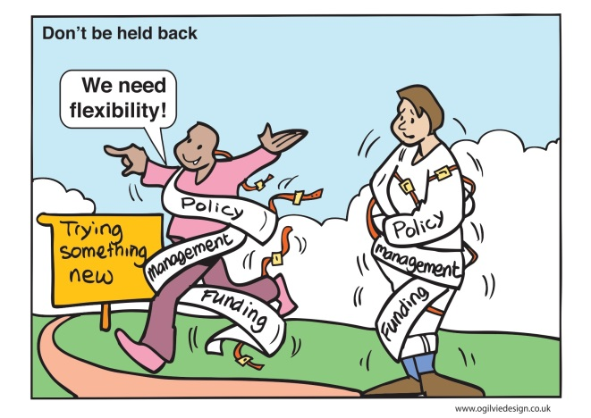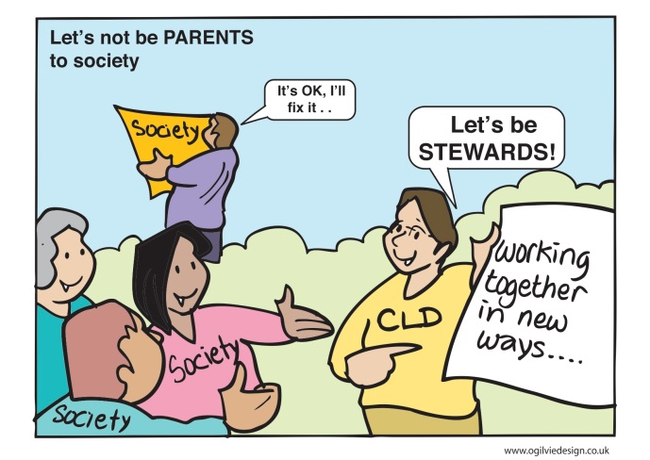

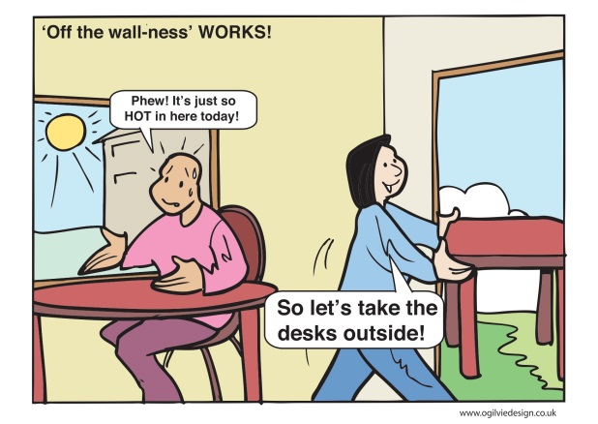

Appendix 4 to follow: after 29th of May.

