“How do we know an online or blended approach to youth participation and youth voice will make a difference in the lives of young people and their communities locally?”

Kate James
12th April 2021

Summary findings

The Edinburgh Napier University Report found that when evaluating online youth participation, there was an over-reliance on traditional evaluation techniques and a scarcity of models for the assessment of the social impact of digital participatory youth projects. Although there was no single tool to capture the range of impacts, Participatory Youth Evaluation methods were the most effective. The rules for assessing online and face-to-face projects are the same and participatory Youth Evaluation should include the following 5 elements: Participation, Co-created knowledge, Power dynamics, Learning, and Play.
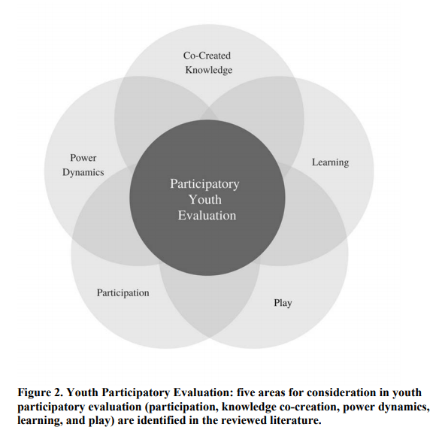

The US Department of Education Report concludes that online and blended learning is as effective as face-to-face learning and, in some cases, more so, though some groups do not fare as well as others. The most successful programmes incorporated extra learning activities and a variety of online delivery methods to keep learning material engaging.

There are many examples of extremely effective online Youth Participation on the TakingITGlobal website which is one of the world's leading networks of young people learning about, engaging with, and working towards tackling global challenges. Also, Camilla Granholm wrote positively about the success of a Finnish Public Health ICT Tool for engagement, however, there are still a number of young people who cannot be part of the virtual society for a variety of reasons and it is important to consider face to face and trans-boundary services to remain inclusive.

Key Points
- There is a wealth of information about the design of online and blended learning but there is little research evaluating the social impact of digital participatory youth projects. We must remember that impact evaluation should be an integral part of the programme design as well as planning engaging activities.

- When evaluating your programme, a Youth Participatory Evaluation method is most effective. The five areas to consider when evaluating a youth participation project are Participation, Co-created knowledge, Power Dynamics, Learning and Play.

- In order to engage most widely and have the greatest impact, make your online engagement meaningful, fun and participant-centred.

- Although online and blended approaches are effective, some young people will be excluded from this platform. We need to be mindful of this and consider alternative ways to make youth participation more inclusive.
Source material

Youth digital participation: Measuring social impact
Published May 17, 2018
Authors Alicja Pawluczuk , Gemma Webster , Hazel Hall and Colin Smith School of Computing, Edinburgh Napier University, Scotland, UK
https://www.napier.ac.uk/~/media/worktribe/output-1112435/youth-digital-participation-measuring-social-impact-2.pdf

Evaluation of Evidence-Based Practices in Online Learning: A Meta-Analysis and Review of Online Learning Studies
Published May 2009
Means, Barbara; Toyama, Yukie; Murphy, Robert; Bakia, Marianne; Jones, Karla
US Department of Education
https://eric.ed.gov/?id=ED505824

Young people and mental health: when ICT becomes a tool of participation in public health in Finland
Published October 2012
Camilla Granholm
https://books.google.co.uk/books?hl=en&lr=&id=ok9jgX7kMVMC&oi=fnd&pg=PA173&dq=ICT+a+tool+for+participation+in+public+health+Finland&ots=4g5gd4_FFK&sig=753JLNWTobvQpgTQ_ObAkgHqXHw#v=onepage&q=ICT%20a%20tool%20for%20participation%20in%20public%20health%20Finland&f=false

TakingITGlobal
Accessed 12th April 2021
https://www.tigweb.org/
Golden Rules for Participation
Accessed 12th April 2021
https://www.youthlinkscotland.org/media/1269/cards_download.pdf

