-
Introduction to Scots Literacy
Guid Fer a Laugh
Level 1- Pack 2

Speakin’
Scots
Gowd
Drouth
Moose
Dyke
Droon
Sicht
Neeps
Licht
Loon
Loon
Snaw
Quine

Feart
Lowp
Airm
COONCIL
Introduction to Guid Fer A Laugh

We are part of the City of Edinburgh Council, South West Adult Learning team and usually deliver ‘Guid Fer a Laugh’ sessions for community groups in South West Edinburgh. Unfortunately, we are unable to meet groups due to Covid-19. Good news though, we have adapted some of the material and we hope you will join in at home.

We are currently developing packs from beginners to level 5. By level 5 you should be able to read, recognise words, understand and write in Scots.

During Covid-19 restrictions the packs will be distributed by community forums, organisations and groups. The activities can be done on your own, in pairs, in groups, with family members or with carers. The activities are informal and suitable for all adults but particularly those who do not have access to computers or social media.

For carers who support older people, you might want to talk them through the pack then leave it with them to read through. This will give them a chance to think about some of the questions and hopefully be ready to join in when you next visit.

The Aims of the Session – Whit’s it a’aboot?

- it’s about learning Scots language and auld words
- take a look at Scots comedy, songs, poetry and writing
- hae a guid laugh at ourselves and others

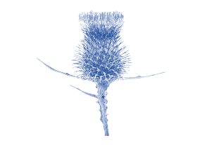
Scots Language
Scotland is a nation of over 5 million people has a range of regional accents and dialects, each with their own sayings and jargon, ranging from Doric to Lallans and Urban Scots.

Whit’s the wurd
(What’s the word)
Listed below on the left are some words in English, but do you know what the words are in Scots. Here’s an example to get you started ‘around is aroon’ in Scots.

Turnips _ _ e _ _
Fight _ _ c _ _
Lad _ o_ _
Girl _ u _ n _
Drown _ _ _ o _
Leap _ _ w _
Frightened _ _ a _ _
Sight _ _ c _ _
Light _ _ _ _ t
Wall _ _ k _

How did you get on? Answers on the next page

Answers to Whit’s the wurd

English Scots

turnips neeps
fight fecht
lad loon
Girl quine
drown droon
leap lowp
frightened feart
sight sicht
light licht
wall dyke

How many did you know?

What Scots word from the list do you like/not like?

Why do you like it/not like the word?

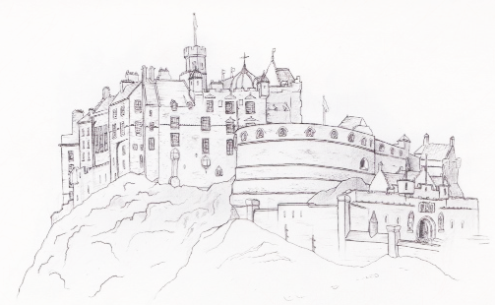

Scots Words
Pit in the wurd
(Put in the word)
Now put the correct word into the sentences below. For example; the Scots word drouth means thirst in English.

He went to the pub as he had a drouth (thirst) on him.

feart sicht neeps fecht lowp

dyke licht quine droon loon

- He ate a plate of _ _ _ _ _ and tatties
- He was _ _ _ _ _ of the dark
- She was a right _ _ _ _ _
- He got in a _ _ _ _ _ in the pub
- He was a braw _ _ _ _
- She was a bonnie _ _ _ _ _
- It is dark, put on the _ _ _ _ _
- He went to the pub to _ _ _ _ _ his sorrows
- His heart gave a _ _ _ _ when he saw her
10. He climbed over the _ _ _ _

How did you get on? Answers on the next page
Answers

- He ate a plate of neeps and tatties
- He was feart in the dark
- She was a right sicht
- He got in a fecht in the pub
- He was a braw loon
- She was a bonnie quine
- It is dark, put on the licht
- He went to the pub to droon his sorrows
- His heart gave a lowp when he saw her
10. He climbed over the dyke
Scots sayings
Match the wurd
(Match the word)

Scots has lots of wee sayings for example;

Scots - As broon as a berry
English - As brown as a berry

Scots - As cauld as ice
English - As cold as ice
Can you match up the words below into the sayings;

coal hoose rat airm bird

hills daisy snaw gowd moose

- As black as _ _ _ _
- As fresh as a _ _ _ _ _
- As muckle as a _ _ _ _ _
- As wet as a drookit _ _ _
- As white as _ _ _ _
- As free as a _ _ _ _
- As wee as a _ _ _ _ _
- As lang as yer _ _ _ _
- As guid as _ _ _ _
10.As auld as the _ _ _ _ _

How did you get on?

Answers on the next page

Answers

- As black as coal
- As fresh as a daisy
- As muckle as a hoose
- As wet as a drookit rat
- As white as snaw
- As free as a bird
- As wee as a moose
- As lang as yer airm
- As guid as gowd
10.As auld as the hills

Now it’s time for a sing along, if you have YouTube you can watch it being performed. Here’s the link, sing along to the chorus. If you do not have YouTube, you can read the lyrics on the next page.

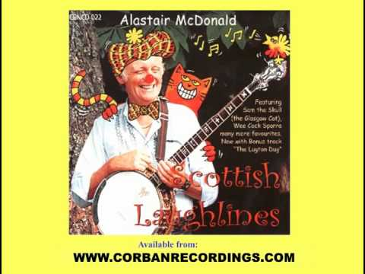

Sam The Skull (The Glasgow Cat) song lyrics by Alastair McDonald

Chorus
I'm a cat, I'm a cat,
I'm a Glasgow cat
And my name is Sam The Skull.
I've got claws in my paws like a crocodile's jaws and a hied
like a fairmer's bull.
I'm no' the kind of cat that sits on the mat
Nor the kind that you gie a hug
But I'm the kind of cat can swallie a rat
Or even the occaisional dug.
Noo I used to roam about in Shettleston
Where they all knew me by sight
"Here's the skull" "Here's the skull"
You could hear them yell
As they vanished intae the night
Noo the polis stations all aroond
Have bars on the windie sills
But they're no to keep the prisoners in
They're to keep oot Sam The Skull
Chorus
I'm a cat, I'm a cat,
I'm a Glasgow cat
And my name is Sam The Skull.
I've got claws in my paws like a crocodile's jaws and a hied
like a fairmer's bull.
Noo I'm no' the kind of cat that sits on the mat
Nor the kind that you gie a hug
But I'm the kind of cat can swallie a rat
Or even the occaisional dug.

Noo one fine day no' so long ago
They all had had their fill
And they sent for the R.S.P.C.A.
To try and catch the Skull
There was naebody could get oot when I was aboot chasin all
the weans up the close
Wettlin on the shoes
Yodelin' the blues
And nonchalantly pickin' my nose
Chorus
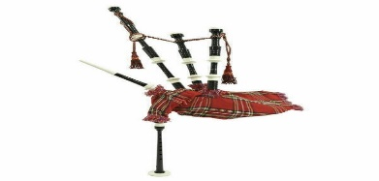
I'm a cat, I'm a cat,
I'm a Glasgow cat
And my name is Sam The Skull.
I've got claws in my paws like a crocodile's jaws and a hied
like a fairmer's bull.
I'm no' the kind of cat that sits on the mat
Nor the kind that you gie a hug
But I'm the kind of cat that can swallie a rat
Or even the occaisional dug.
Aboot half past two
The boys in blue
Arrived in their Escort van
Right roon the back
One had a sack
The other had a mallet in his hand
I watched them creep tae the back of the close,
Then I casually strolled tae the van
I jumped through the door
Stuck my foot tae the floor
Everything had gone tae plan
You can hear them say doon Shettleston way, "What became of
Sam the Skull?
He had claws in his paws like a crocodile's jaws, and a heid
like a framer's bull."
Just you tell them for me that I'm still running free and
never a day is dull
It may sound absurd
But I'm livin' wi' a bird in a single end in Maryhill
Chorus
I'm a cat, I'm a cat,
I'm a Glasgow cat
And my name is Sam The Skull.
I've got claws in my paws like a crocodile's jaws and a hied
like a fairmer's bull.
I'm no' the kind of cat that sits on the mat
Nor the kind that you gie a hug
But I'm the kind of cat that can swallie a rat
Or even the occaisional dug.

Dae Ye Ken that…………

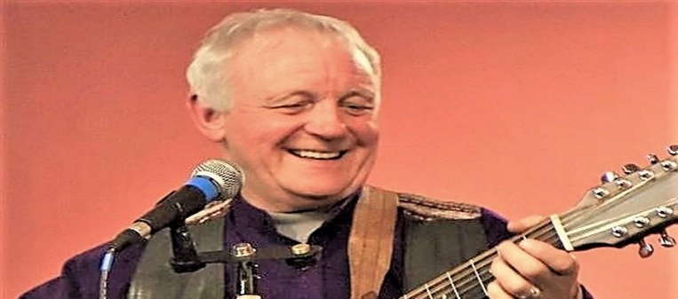

Alastair McDonald (born 28 October 1941) is a Scottish banjo-playing folk/jazz musician, probably most famous for his recordings of Jim MacLean's folk songs, such as The Barras and The massacre of Glencoe, but also for some humorous songs, such as the jazz comedy song Sam the skull, about a Glasgow cat.
McDonald has mainly recorded songs written by other songwriters, for example Robert Burns and Jim MacLean, but has also written songs himself (Culloden's Harvest, The Village Green at Gretna), and reworked traditional songs (The Bell Rock Light, Mingulay Boat Song). Though quite well known – he has toured US (every state except Hawaii and Alaska), Canada, Israel, Denmark, Thailand and several more countries – not much is spoken of him in media. Much of his work in recent years has been political song, usually socialist and/or republican, such as his tribute song to John MacLean and Wee German Lairdie. He supports Scottish independence. He is also seen regularly performing the honky tonk. He lives in Netherlee, East Renfrewshire
Joke fae the Poke

It time for a wee chuckle. We usually ask people to pick a joke from the bag and share it with the group. As you are in your house, we have added a few for you to read. It might help if you read out

The queen hosts a garden party in Scotland. When the Scottish waiter arrives with a tray of cakes she asks, “Is that a scone or a meringue.?”
The waiter replies “Naw yer quite right that’s a scone.”

Two cows standing in a field, which one is going on holiday?
The one with the wee calf.

A Glaswegian woman goes to the dentist and settles into the chair. “Comfy” the dentist asks, “Govan” she replies.

A lassie phones her dad after a night in the pub and says: "Can you come and pick me up? I've missed the last bus and it's pouring with rain." “Okay says her dad, where are you ringing from.” The girl replies, “From the top of my head right down to my knickers.”

We’d like to hear your jokes and share them with others. We will include funniest in future packs. My contact details are at the back. You can phone or send them in by email.

Word Search

Find the Scots Wurds

Z | J | N | H | U | H | T | F
B | W | O | T | Q | S | H | E
N | K | O | O | U | I | C | A
I | E | L | R | I | C | I | R
Y | U | E | D | N | H | L | T
D | U | S | P | E | T | H | R
E | K | Y | D | S | N | L | H
D | R | O | O | N | C | H | N

DROON | DROTH | DYKE
FEART | LICHT | LOON
NEEPS | QUINE | SICHT

We hope you have enjoyed Scots Literacy pack 2, now it’s time for you to….

Hae Yer Say P

We are planning on developing more Scots Literacy packs and to help us do that we would like you to phone or email your favourite jokes, Scots words, sayings and anything else you’d like to see include in future packs. My email and phone are below.

- Did you enjoy it? If yes, what did you like?

- If not, why not?

- Anything else you would like to see in the pack?

Course material developed by Derek Suttie, Scots Literacy Tutor.
If you would like more information about Scots Literacy Sessions, contact:

Lydia Markham, Lifelong Learning Worker (Adult Learning), SW Locality, City of Edinburgh Council
Lydia.markham@ea.edin.sch.uk Mobile: 07719 420 424

