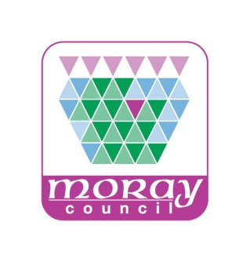
The Moray Council
Education, Communities & Organisational Development

Adult & Family Learning

Individual Learning Plan

Learner Name:
Tutor:
What would you like to be doing in, say, two years’ time? (long term goals) – think about individual/family/community/working life.
What would you like to begin with (SMARTER short-term goal, see overleaf)
1)

2)

How do you like to learn? (visual, listening, doing, etc)
Is there any other information you wish to tell us that may be relevant to your learning?
On a scale of 0 to 10, how confident do you feel about your skills?
(Please circle a number below; 0= not confident, 10 = very confident)

0 1 2 3 4 5 6 7 8 9 10

Learner Agreement
I understand that, in order to make progress with my learning, I need to attend regularly and do some practice at home in between sessions.
I agree to attend sessions in a row. After these sessions, I can choose to stop attending or continue with my learning and negotiate a new attendance agreement.
If I am unable to attend because of ill health, I will inform my ALC as soon as possible before the session date and time.
Learner Signature: |  |  | Date:
ALC Signature: |  |  | Review Date:

S
Specific – Is the learning goal clear? E.g. gain ‘confidence in reading’ is not, but ‘to be able to read Gatehouse level 1 with confidence’ is. ‘Get better with numbers’ is not, but ‘learn how to add up decimals up to 2 places’ is.
M
Measurable – You can use reader levels; SQA levels or agree with the learner what they can do and what they want to be able to do e.g. confident with 2 times tables but wants to learn 5 & 10 times table.
A
Achievable – Can the goal really be achieved by attending Essential Skills for an hour once or twice per week? Is this service appropriate?
R
Realistic - Acknowledge long term goals but focus on the short term goals which need to be achieved first. Are the goals achievable for the learner? Is this service appropriate?
T
Timed – With new learners, set a goal which can be achieved in 4 sessions- it may just be turning up on time. Review with learner and, if they plan to continue, set a goal to be achieved in an agreed number of sessions (usually 12), review and update learning plan as necessary.

E
Evaluated – What impact has engagement with the service had? What evidence is there to prove the progress or lack of progress? How can things be improved? Do we need to involve the referrals agency?
R
Reviewed – With the learner, carry out an informal review at the end of every session. Reflect on the feedback and consider if things are on target and if not, what needs to be done to get things back on target. Do we need to update the ILP?

