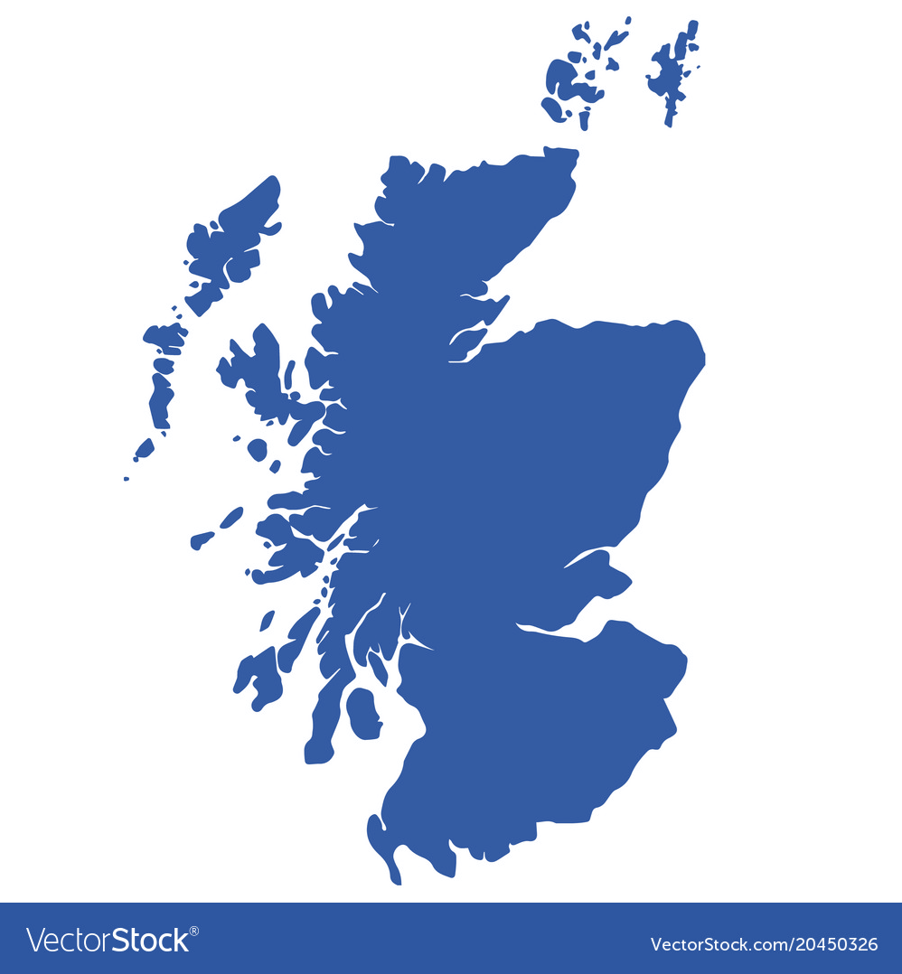
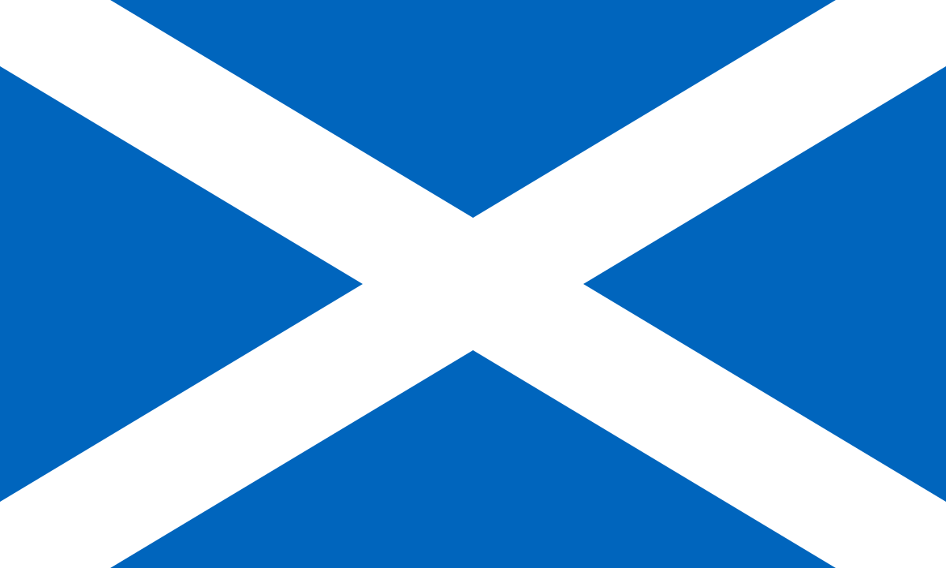
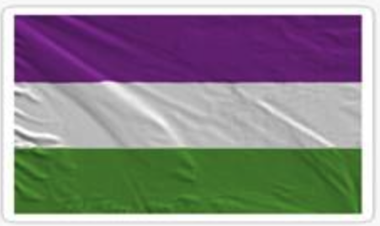
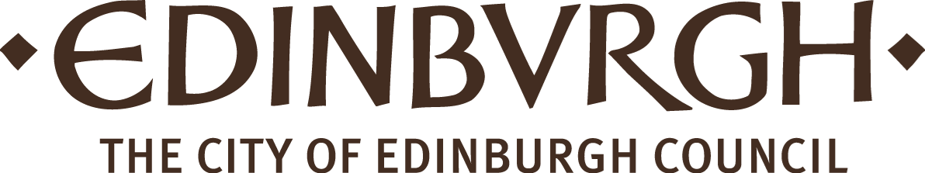
Introduction to Scots Literacy
Guid Fer a Laugh
Level 2- Pack 7

Bauld
Wummin

Carfuffle

Gallus
Mither
Blithe

Fechter
Strang
Snell
Loon
Pooer
Freen

Setten

Doucht

Bonnie

Smeddum
Quines
Speakin’
Scots
COONCIL
Introduction to Guid Fer A Laugh

We are part of the City of Edinburgh Council, South West Adult Learning team and usually deliver ‘Guid Fer a Laugh’ sessions for community groups in South West Edinburgh. Unfortunately, we are unable to meet groups due to Covid-19. Good news though, we have adapted some of the material and we hope you will join in at home.

Development of Packs
Following feedback from participants we plan to develop packs from beginner level 1 to 5 with 4 packs at each level. This will allow participants to gradually increase in confidence, recognising and understanding Scots. By level 5, participants should be able to: read, recognise, understand and write in Scots.

Distribution During Covid-19
During Covid-19 restrictions we are emailing packs to community forums, organisations, groups and individuals.

Using the packs
The packs can be done in pairs, small groups or individually. They are being used by: families, carers, support workers and individuals. The activities are suitable for all adults but particularly those who do not have access to computer and internet.

Adapting Packs
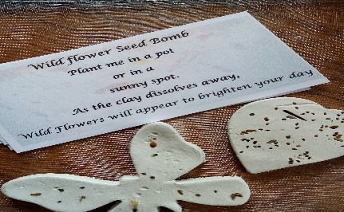
The packs can be adapted to suit participants needs. For example, Karen McCurry emailed saying their “Our Outreach Worker is visiting people today who live alone with no family or carers coming in, so she is going to print off booklets and do the activities with them. We have made ceramic and crochet hearts. It's a great resource for us to share with people in this way. Thanks for emailing us Karen.
The Aims of the Session – Whit’s it a’boot?

- it’s about learning Scots language and auld words
- takes a look at Scots comedy, songs, poetry and writing
- hae a guid laugh at ourselves and others

See some of the feedback folk have sent in at the back o’ the pack. Keep sending us yer braw contributions. We’re teaming up with Age Scotland again for April’s edition which will have a Spring/Nature theme. So please get your contributions to us …….now.

On March 8th we celebrated International Women’s Day. For this edition we want share with you some of the braw Scots wimmen who’ve made a difference and wee bit aboot the history of the women’s suffrage movement. This is a bumper pack so feel free to select what you want.

International Wummin’s Day
Whit’s it a’boot?

As we get ready to go to the polls again in May to elect our Members of the Scottish Parliament it’s a good time to remember the long struggle for women’s right to vote and the women in Scotland who campaigned for change. It was a struggle lasting almost 100 years. The vote was granted to women over the age of 30 in January 1918, at the end of the First World War. In 1928, the year Emmeline Pankhurst died, women in Great Britain finally achieved equal voting rights to men.


Dae ye ken……..

1866 – First petition by women for the right to vote presented in the House of Commons.

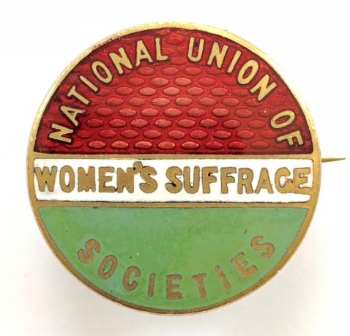
1867 - The National Scottish Federation, National Union of Women’s Suffrage Societies (NUWSS) The first Scottish Women’s Suffrage Society was formed in Edinburgh on 6th November 1867. They built support through holding large public meetings and debates, taking part in rallies, and collecting signatures for annual petitions to Parliament.

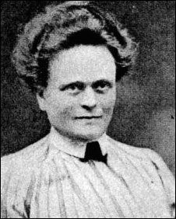
Elsie Inglis (1864-1917) Her work experience of the standard of medical care available to women and the dismal living conditions of working class women, led to her becoming politically active and playing a prominent role in the women’s suffrage movement. As honorary secretary of the committee of the Edinburgh National Society for Women’s Suffrage she became involved in organising and supervising processions, demonstrations and speakers. Elsie wis fu o smeddum.

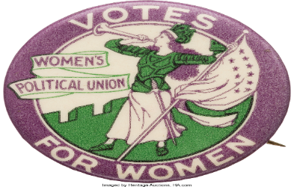
1906 - The Women’s Social and Political Union (WSPU) Activities included selling literature, holding meetings and speaking tours, processions and campaigning at election times. It was only after 1913 that militant activity grew in Scotland with attacks on property including putting acid in pillar boxes, cutting telephone wires, damaging the King’s portrait in the National Gallery and burning down the main stand at Ayr Race Course.

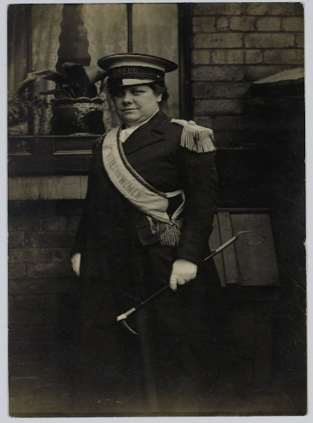
Flora Drummond’s (1878 -1949) campaign of disruption resulted in nine terms of imprisonment and five hunger strikes. In 1908 she was pictured outside Holloway prison greeting the release of another Scottish suffragette, Mary Phillips, alongside a banner “To Mr. Asquith. “Ye Mauna Tramp on the Scottish Thistle laddie.” Flora was known as “The General” and organised many of the great suffrage marches including the 1909 Edinburgh procession.
Her portrait hangs in Scottish National Portrait Gallery in Edinburgh.
Flora’s whit we’d call the ‘high heid yin’.

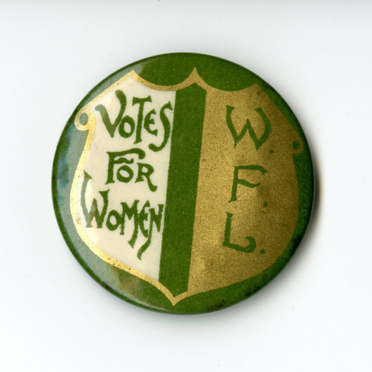
1907 - The Women’s Freedom League - The Women’s Freedom League had strong representation in Scotland with premises in both Glasgow and Edinburgh. Members campaigned on equal pay for equal work and against injustices in the legal system. The League adopted a policy of passive resistance with members refusing to pay taxes – no taxation without representation. Members boycotted the 1911 census by arranging to be away from home on the day the census was counted.

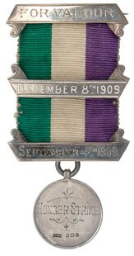
Many women were force-fed. The Women’s Social and Political Union awarded a range of military-style campaign medals to raise morale and encourage continued loyalty and commitment to the cause.

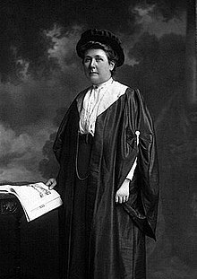
Dr Grace Caddell (1855 -1918) was President of the WSPU Leith branch but in 1907 joined the newly created Women’s Freedom League. Grace Cadell’s home on Leith Walk in Edinburgh became a sanctuary for fellow suffragettes. She was medical advisor to the hunger strikers who were released into her care including the artist Ethel Moorhead. Imprisoned several times and released under the “Cat and Mouse Act”, Ethel Moorhead was the first Scottish suffragette to be forcibly fed in Calton Jail in 1913. Grace is whit we’d call snell.

A Gude Cause Maks a Strong Arm

In 1909 hundreds of suffragists from all over Scotland marched in a procession in Edinburgh. There were women pipers, Newhaven fishwives, women graduates, doctors and teachers. Hundreds of people turned out to cheer the marchers.

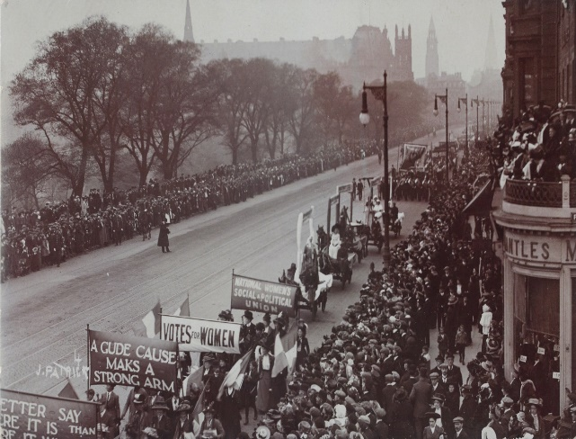

“Scots wha hae votes – men.
Scots wha hae na – women.

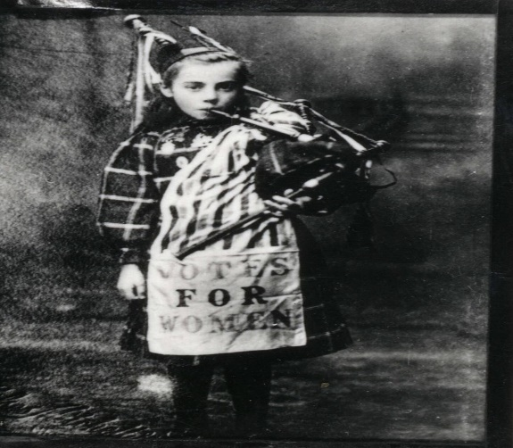
Bessie Watson (1900- 1992) One of the youngest pipers at the procession was Bessie Watson (aged 9) who joined the Women's Social and Political Union (WSPU) with her mother. Bessie played the pipes at marches and on the platform of Waverley Station as trains departed taking convicted women's rights campaigners to Holloway Prison. She also played outside Calton Jail for the suffragettes imprisoned there. Bessie is whit we’d call blithe.

1913 - The Cat and Mouse Act or the Act’s official name, the ‘Prisoners Temporary Discharge for Ill Health Act’ was introduced to facilitate the re-arrest of suffragettes after they had recuperated for their ‘illness’ from hunger striking. Ye hud tae be a bonnie fechter to survive that!

1914 -1918 – World War 1 - Disrupted women’s suffrage as many of them supported the war effort working in the absence of men.

1918 – Women gain the vote – The Representation of the People Act granted women over 30 right to vote if they were married or a member of the Local Government Register. This was seen as a reward for their contribution to the war effort.

1928 – Women were granted suffrage equal to men. The Equal Franchise Act 1928. The age for women was lowered to 21 and property qualifications reduced to the same as men.

Thegither they a campaigned
Imprisoned, tortured, sair wi pain
Brave they wur back then and the day
Wummin! Dinnae let it a’be in vain
Mind’n vote oan the 6th o’ May

Whit’s yir favourite Wurds
We are focusing on wummin who have done inspiring things in their lives. We are looking at wummin who stood up fer thersel and ithers. Wha inspires you? Whan ye you think o them, which wurds come to mind? Heres some o oors.

Richt Strang Mither Smeddum Blithe

Which of these dae ye like best? Use them and your ain wurds tae mak sentences. Play aroon wi them.

Whit’s the difference between a
suffragette and a suffragist?

From the perspective of some campaigners, the suffragists failed to achieve votes for women by peaceful, ‘respectable’ methods. Many disillusioned women began to advocate a more militant approach. These groups became known as the suffragettes, and they adopted the motto 'Deeds not Words'.

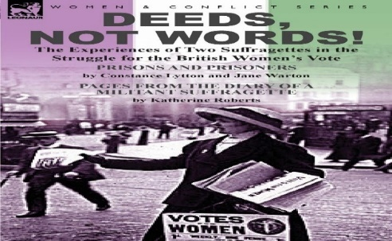
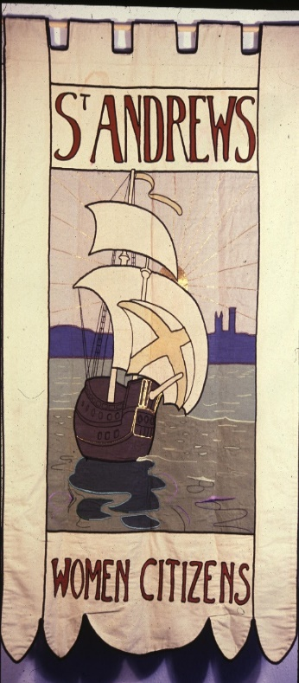
Banners
There are few surviving women’s suffrage banners in Scotland. This banner was made in 1910 for the St Andrews branch of the National Union of Women’s Suffrage Societies. It was made by Grace Cruttwell, art teacher at St Leonards School, St Andrews. It’s believed that after women won the right to vote, the banner was used by the St Andrews Branch of the Women’s Citizens Association who changed the stitching, adding their name to the banner.

Image courtesy of Fife Cultural Trust (St. Andrews Museum) on behalf of Fife Council.

Whit’s the Wurd
Below are some English words, whit are the Scots wurds fur them?
English Scots
Bold _ a _ l _
Strong _ t _ a _ _
Disturbance C _ r _ _ f _ l _
Quick Witted S _ e _ l
Woman W _ _ m _ _
Proud V _ u _ t _ _
Spirit S _ e d _ _ _
Cheerful B _ _ t _ _
Right R _ _ h _
Friends _ r e _ _ s

Answers on next page

English Scots
Bold Bauld
Strong Strang
Disturbance Carfuffle
Quick Witted Snell
Woman Wummin
Proud Vauntie
Spirit Smeddum
Cheerful Blithe
Right Richt
Friend Freen
How did ye get on? Hae a play aboot wi them.
We like blithe as it means cheerful and it makes us smile.
Wearing the Colours
Each of the women’s suffrage organisations devised their own colour scheme, and displayed their colours in sashes, banners, badges and jewellery to advertise their allegiance for the movement, very like the colours worn by football supporters today.

The National Scottish Federation, National Union of Women’s Suffrage Societies (NUWSS) - Red, Green, White

The Women’s Social & Political Union (WSPU) - Purple, White Green

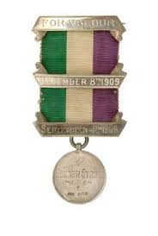
Women’s Freedom League - Gold, Green, White

Whit colours wid ye wear? Which o the three organisations dae ye maist identify wi?

Pit the Wurd In

Put richt Scots wurds into the sentences, select from the wurds
below

Quines Pooer Gallus Mither Doucht Rammy
Setten Bonnie Airmed Tuff Hantel, Stooshie

- Aberdeen wummin are called _ _ _ _ _ _.
- A _ _ _ _ _ _ of wummin went oan strike.
- She wis a big _ _ _ _ wummin.
- The wummin kicked up a _ _ _ _ _ at the meeting.
- The Union representative was a richt _ _ _ _ _ _ wummin.
- My _ _ _ _ _ _ wis a braw wummin.
- She was a _ _ _ _ _ _ young lassie.
- _ _ _ _ _ _ with a gude cause they fought on.
- There was a _ _ _ _ _ _ _ _ when the police came to break up the protest.
10.She looked _ _ _ _ _ _ in her suffragette outfit.
11.When she spoke out she was full of _ _ _ _ _ _.
12.The women together had a lot of _ _ _ _ _.

Answers on the next page.

Have some fun with the words.
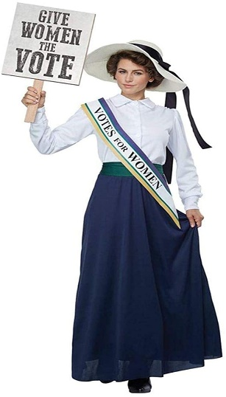

Here’s some meanings:

Hantel – Group
Setten – Resolute
Dought – Vigour
Pooer - Power

Answers

- Aberdeen wummin are called quines.
- A hantel of wummin went oan strike.
- She wis a big tuff wummin.
- The wummin kicked up a rammy at the meeting.
- The Union representative was a richt gallus wummin.
- My mither wis a braw wummin.
- She was a setten young girl.
- Airmed with a gude cause they fought on.
- There was a stooshie when the police came to break up the protest.
10.She looked bonnie in her suffragette outfit.
11.When she spoke out she was full of doucht.
12.The women together had a lot of pooer.

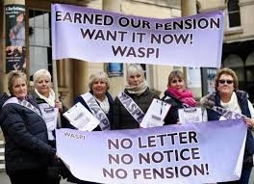

Women Against Pension Inequality

Known as WASPI Wummin
Nae warnin tae them wiz given
State Pension age fur wummin increased
Their hopes for retirement ceased!

Sum Saying & Phrases

In Scots we have our oan saying and phrases. Select from the sayings below. Put them into the right sentences.

“a weel stocht hert” “a gey sair fecht” “up fer a stooshie”
“mak nae mustake mannie” “big bits (boots) tae fill”
“neathin ventured, neathin gained” “The wummin gey it laldie”
“twa cannae play patience” “A gude cause maks a strong arm”
“Tak the lang wey roon”

- Now she is gone she leaves _ _ _ _ _ _ _ _ _ _ _ _ _ _ _ _ _ _
- She said “ _ _ _ _ _ _ _ _ _ _ _ _ _ _ we will win.”
- She was really generous she had _ _ _ _ _ _ _ _ _ _ _ _ _ _ _
- In the end we wull win, even if we _ _ _ _ _ _ _ _ _ _ _ _ _ _
- They had a good time, _ _ _ _ _ _ _ _ _ _ _ _ _ _ _ _ _ _ _ _ _ _
- She shook her heid and said “It’s _ _ _ _ _ _ _ _ _ _ _ _ _ _ _ _
- In the struggle for the vote they said a _ __ _ _ _ _ _ _ _ _ _ _ _
- The wummin wer _ _ _ _ _ _ _ _ _ _ _ _ _ _ _ _ _ _ _ _ _ _ _ _ _ _
- She said I am on my own in this one _ _ _ _ _ _ _ _ _ _ _ _ _ _ _
10.As the saying goes _ _ _ _ _ _ _ _ _ _ _ _ _we’ll tak oor chances.

Answers on the next page.

How did you get oan? Take the phrases and see how many other ways you can use them or use your own phrases in sentences.

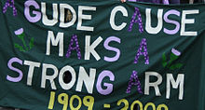
We like “a gey sair fecht” because it really does remind us of what a struggle life can be. We also like “a gude cause maks a strong arm” because it was a phrase that helped wummin tae get the vote.

Answers

- Now she is gone she leaves “big bits tae fill”
- She said “mak nae mistake mannie” we will win.”
- She was really generous she had “a weel stocht hert”
- In the end we wull win, even if we “tak the lang wey roon”
- They had a good time, “the wummin gey it laldie”
- She shook her heid and said, “It’s a gey sair fecht”
- In the struggle for the vote they said “A gude cause maks a strong arm”
- The wummin were “up fer a stooshie”
- She said, I am on my own in this one “twa cannae play patience”
10.As the saying goes “naethin ventured, naethin gained” we’ll tak oor chances.

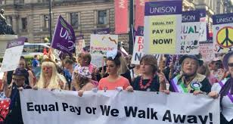
Over the years things have improved for women however, there are still many inequality issues affecting women. Here’s one example from The Women’s Equality Party, ‘Women still occupy the lowest-paid jobs, three-quarters of the people who've done minimum wage jobs in the last 10 years are women. Working women earn 81p for every pound a man earns and at the current rate it will be 70 years before that gap eventually closes.’

Women’s International Day is about raising awareness of issues affecting women. It’s also a day for coming together and celebrating achievements.

Which wummin inspire you? Here’s some more of ours.
Some inspiring Scots wummin
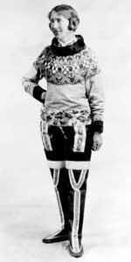
Explorer – Isobel Wylie Hutchison (1889-1982) – was a Scottish botanist, filmmaker, author, poet and artic explorer. Between 1927 and 1936, she travelled the Artic by any means available including rowing boats, snowshoe and dog sledges. She walked across Iceland solo when everyone told her not to. She was the first Scotswomen it’s said to travel in Greenland.

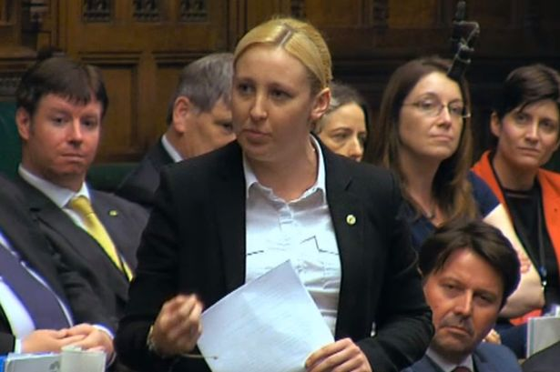
Politics –Mhairi Black (born 1994) Member of Parliament for Paisley & Renfrewshire South. When elected in May 2015, she was 20 years and 237 days making her the youngest MP elected to the House of Commons since at least the Reform Act of 1832. Her maiden speech criticised the government’s approach to unemployment. She said “Food banks are not part of the welfare state. They are a symbol that the welfare state is failing.”

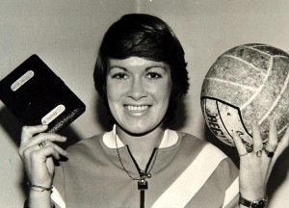
Sport - Rose Reilly (Born 1955) –Voted the world’s best female footballer in 1983. Rose Reilly is currently one of only 14 football players and managers in the Scottish Sports Hall of Fame. She is also a World Cup winner and trailblazer for women’s football. At just 17 having played 10 games for the Scotland Women’s team, Rose moved abroad to become a professional footballer.
Mair Inspiring Wummin

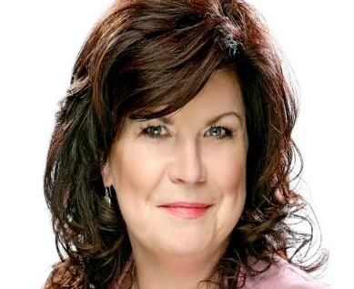
T.V. & Comedy - Elaine C. Smith (Born 1958) is a Scottish actress, comedian, and political activist. She has starred in various tv and stage productions and is a political campaigner. The number of women seeking medical advice about breast cancer has increased by 50%, following an advertising campaign featuring Elaine C Smith.

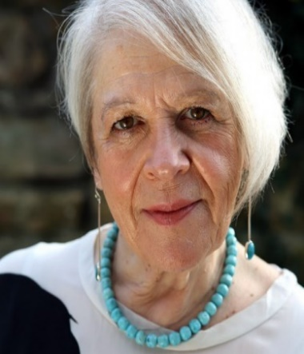
Poet - Liz Lochhead (born 1947) is a Scottish poet, playwright, translator and broadcaster. Between 2011 and 2016 she was the Makar or National Poet of Scotland, and served as Poet Laureate for Glasgow between 2005 and 2011. For 25 years, Lochhead has been the distinctive female voice of Scotland. Gallus, inquisitive, accusing and playful.

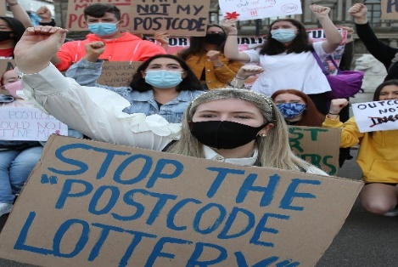
Protest Organiser- Erin Bleakley (Born 2003) organised a protest in 2020 when exams were cancelled due to COVID 19. This resulted in the Scottish Qualification Authority (SQA) down grading pupils from the most deprived areas by 15.2% compared with 6.9% in the most affluent parts of the country. Erin organised a protest in Glasgow saying, “How can anyone expect to close the attainment gap when your hard work can be wiped out based on your postcode?”

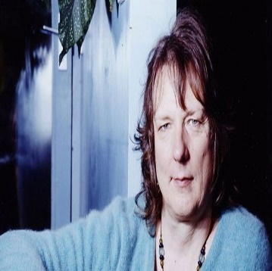
Playwright - Jo Clifford (born 1950) is one of Scotland's most accomplished playwrights. She has written more than 80 plays, which have been performed in theatres throughout Scotland and the world. The Saltire Society's Sarah Mason says Jo is a role model for transgender people in Scotland. She’s whit we’d call setten.

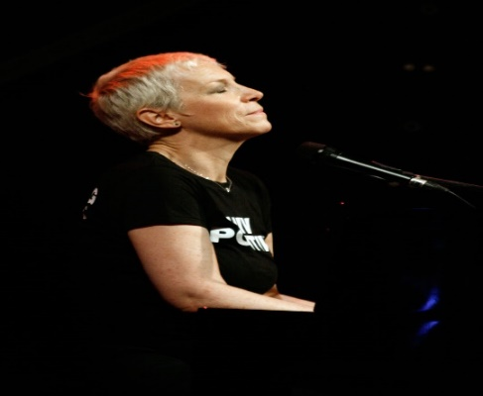
Singer - Annie Lennox – (Born 1954) Scottish singer, songwriter and political activist Annie Lennox achieved international success in the 1980s as one half of the Eurythmics. With eight Brit Awards, including six for Best British Female Artist, she has won more than any other female artist. She’s whit we’d call a braw chanter.

For many of us, our inspirational women are our mums, grannies, aunties, sisters and the countless ordinary everyday women who make a difference to their families and communities. Here’s one women who is representative of lots of women activists.

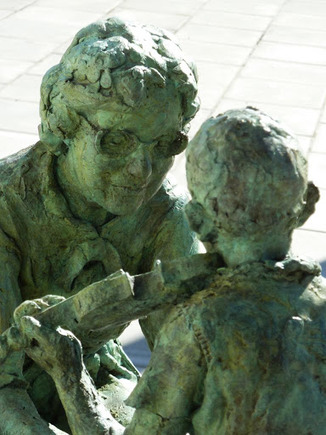
Community Activist – Helen Crummy (1920 – 2011) was a founder of the Craigmillar Festival Society in Edinburgh. She became one of the first residents in a new council housing estate at Craigmillar in 1931. The estate later became one of the poorest areas of Edinburgh. She asked the headmaster of the local primary school if her son, could be taught to play the violin. He replied that it took the school all it’s time to teach these children “all three R’s.” Helen with the local mothers group decided to show how talented their children were and started The Craigmillar Festival which grew to gain international acclaim.
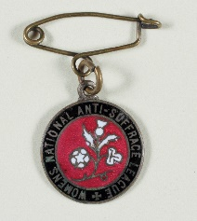
Scots Wummin – The Quiz

There are 3 choices but only one is the correct answer.
Dinnae worry if ye pick the wrang yin, it’s only a wee bit fun.

- What name was Flora Drummond known as?
a) Captain b) The Major c) The General

- Jackie Kay is a famous?
- Singer b) Politician c) Poet

- Why was the ‘Cat and Mouse Act in 1913’ introduced?
- Force feed women b) Re-arrest women c) Starve Women

- Which War interrupted the women’s suffrage movement?
- First World War b) Korean War c) Second World War

- What kind of campaign methods where used by The Women’s Freedom League?
- Arson Attacks b) Passive resistance c) Petitions

- Which sport is Rose Reilly is famous for?
- Footballer b) Hockey c) Athletics

- Which year were women over 30 granted the vote?
a)1919 b) 1918 c) 1920

- What colours did the Women’s Social and Political Union wear?
- Green, white gold b) Red, white, green c) Purple, white,
green
- In 2015 Mhairi Black was the youngest MP elected to the House of Commons, what age was she?
- 21 years b) 20 years c) 22 years

- What musical instrument did wee Bessie Watson play?
- Violin b) Accordion c) Bagpipes

- What honorary role did Elsie Inglis hold in the Edinburgh National Society of Women’s Suffrage?
- Secretary b) Treasurer c) Chairwoman

- What year was the voting age for women lowered to 21 the same as men?
- 1930 B) 1928 c) 1919

- In 1909 hundreds of suffragists from all over Scotland marched in a procession in which Scottish city?
- Edinburgh b) Aberdeen c) Glasgow

- Isobel Wylie Hutchison was famous for?
- Mountaineering b) Sailing c) Exploring

- What year did Erin Bleakley organise a protest about SQA down-grading exam results according to post code?

- 2020 b) 2019 c) 2021

How did you get on? Hae a guid blether aboot yer answers

Answers on the next page
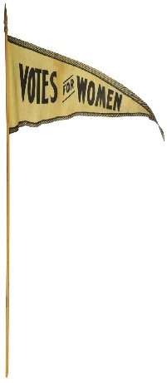
Answers

- (c) The General
- (c) Poet
- (b) Re-arrest
- (a) First World War
- (b) Passive resistance (refusing to pay tax)
- (a) Football
- (b) 1918
- (c) Purple, white, green
- (b) 20 years
10 (c) Bagpipes
11 (a) Secretary
12 (b) 1928
13 (a) Edinburgh
14 (c) Exploring
15 (a) 2020

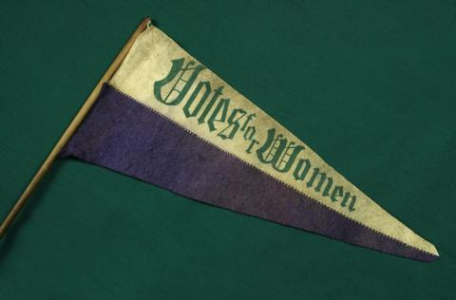

Wurd O’ the Pack
Fechter

This is the wurd that best sums up the women who fought for the vote. It means fighter, in Scots it goes really well with the wurd bonnie this makes a BONNIE FECHTER, which means a really, really guid fighter, wha never gies up.

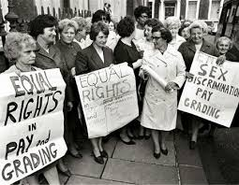
Grannie Clerra always telt us aboot her pals, but maistly aboot Rona and Rosie, especially roon a boot International Wummin’s Day. Grannie Clerra wid tell us a’aboot hoo Rid Rosie Reed a’n her freen Rona were lichts o’ the community.
She telt us aboot hoo they led wummin oot on a strike an aboot how the three o them focht the factory owner fur mair pay. Grannie Clerra telt us aboot when the factory owner goat knighted, he hud tae be telt tae get up as he didnae ken whit the Queen meant when she said “Arise!”
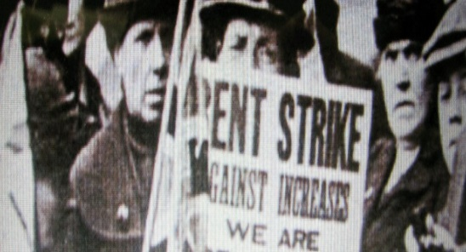
Best o a Grannie Clerra telt us a aboot “The Elsies”. The Elsies were set up by Rona and Rosie to celebrate outstanding wummin in the community. They were rerr occasions, they also celebrated the great Elsie Ingilis. Rona a’n Rosie baith won Elsies thersels and Grannie Clerra said they were two o the bonniest fechters she ever met and were the bonniest companie she kent. Rona kept the Elsies going for years. Grannie Clerra said “The Elsies shud be broucht back, it was a scandal that they wir stopped.” Rona still has loads o stuff and Rona telt us that Grannie Clerra won an Elsie herself. She goat it fur organising a rent strike in her street. A the wummin led by Clerra stormed the Council and goat the rent pit doon.

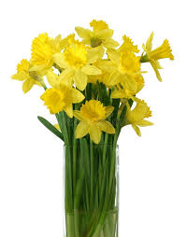
On March the 8th every year Grandie Chay wud go an pick a bunch o wild daffies tae gae tae Grannie Clerra. He wud gie them tae her an say, “Tae a richt bonnie fechter.” She wud reply “Aye an we wummin we still need tae keep oan fechtin!” Grandie Chae Wud smile, sigh an say “Aye if it wisnae fur the wummin whit wud we dae.”

Who were the wummin who inspired you? Which wummin wid ye call:
Fechters, Bonnie Fechters

Corona Virus in Scots

Weel the jab is here. However, the virus is not going away. It is still oot there. It is important to mind and be vigilant, keep safe and weel.

Get the jab, the jab is fab
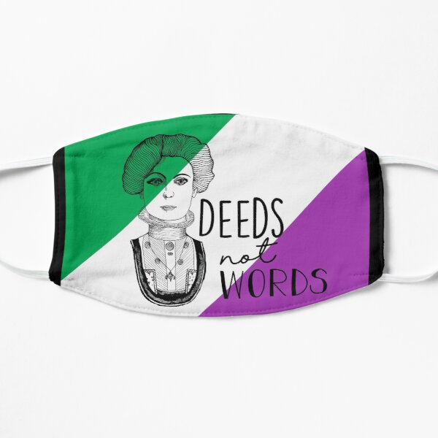
But always remember

Dinnae get ower close and
Dinnae mak us ask, wear a mask

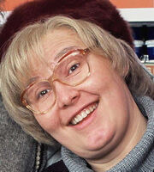
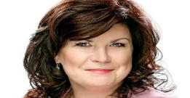
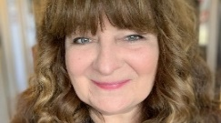

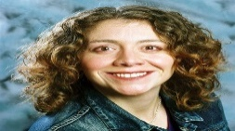

At the top and bottom of the page we’ve included photo’s of some funny Scots wummin, you’ll recognise them fae the telly but do you ken their names?

Joke fae the Poke

A Dundee woman in hospital giving birth, "Well done, it's' a boy, what are you going to call him?" the midwife asks. The woman replies "Nathan" the midwife says, "aw come on, you have to call him something."

“Hae ye no goat a last wish Sandy?” “Aye a wud like a wee bit o yon boiled ham.” “Wheest man” said Maggie, “Ye ken fine that’s fur the funeral.”

Arguing with a Scottish woman is a lot like battling a tornado except a tornado is calmer.

Scottish women are nae bossy, they’re jist better at knowin whit tae dae.

A sense of humour’s jist common sense gone dancin.

“Have you goat a wild duck?” “Naw but I’ve goat one I cud aggravate fur ye.”
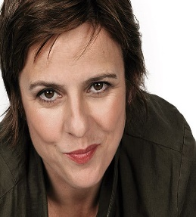
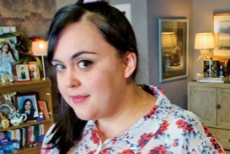
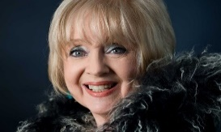
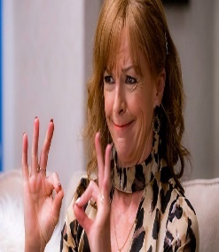
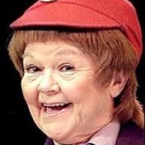
Poem/Song O’ the Pack

They Sent a Wumman by Nancy Nicolson. It’s a song written by a woman to be sung by a man. It’s about sexist stereotyping. Please note in Scots, there are a few different spellings of woman, wumman, wummin, weemen.

If you have access to YouTube you can watch the McCalmans singing on this link, https://youtu.be/dUMZyLDQ7gU
They Sent a Wumman
Lyrics/Music: Nancy Nicolson



Ah sent for the doctor, Ah telephoned the day
The doctor wis an affa time a-comin
Ah sent for the doctor, bit sorry for tae say
A doctor never came, they sent a wumman
But Ah let her make me better
Then Ah asked her could she no get intae nursin
Ah sent for the doctor, bit when she went away
Ah couldnae understan why she wis cursin
Ah sent for the pilot, Ah telephoned the day
The pilot wis an affa time a-comin
Ah sent for the pilot, bit sorry for tae say
A pilot never came, they sent a wumman
But she roared off an she soared off
Then in she came an made a perfect landin
Bit why she simply widnae juist hae been an air hostess
Ah've got tae say is past ma understandin
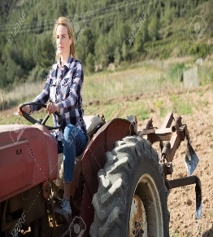
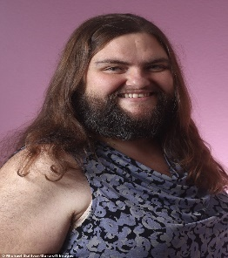
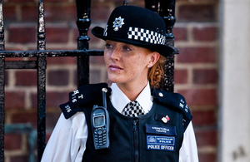
Ah sent for the polis, Ah telephoned the day
The polis wis an affa time a-comin
Ah sent for the polis, bit sorry for tae say
A polis never came, they sent a wumman
But she nabbed the boy that grabbed the
Payroll fae the office in the High Street
But still Ah felt she should be telt it's no lassie's job
Ah widnae wint her on the beat in my street
Ah sent for the fairmer, Ah telephoned the day
The fairmer wis an affa time a-comin
Ah sent for the fairmer, bit sorry for tae say
A fairmer never came, they sent a wumman
Bit her coos were an her soos were
The very best, the top of a' the biddin
An a' Ah did wis ask her hed her faither steyed at hame
The next Ah kent wis Ah wis in the midden
So Ah prayed til God Almichty, Ah prayed til him the day
The guid Lord wis an affa time a-comin
Ah prayed til God Almichty, an Glori-Glori-Ay
The Great Almichty came, she wis a wumman
An she viewed me, She How-d'ye-do-ed me
Said, Ma lad, ye willne listen, ye're no learnin
So here's a little lesson, boy, ye're comin back again
An this time as a wumman ye're returnin

Hae a blether aboot the poem/song.
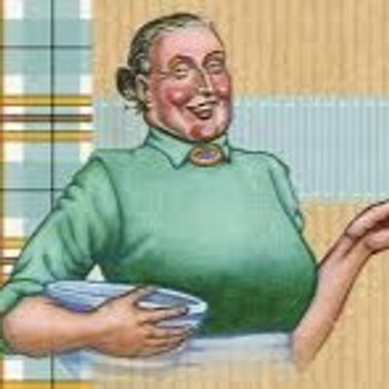
Maw Broon Visits a Therapist - Jackie Kay

Crivens! This is jist typical.
When it comes tae talking aboot me,
well, A’ jist clam up. Canny think whit tae say.

Weel, weel. A’m here because
A’ canny hawnle life, ken whit A’ mean,
because everything is awfy
And A’m no masell.

A’ dinny ken who Maw Broon is anymare.
A’ canny remember ma Christian name.
A’ remember when A’ wis a wean,
folks cried me something.

The idea o ’me ever being a bairn
is impossible. A’ feel A’ve aye worn
this same pinnie and this heid scarf
A’ve got on the noo.

How come you’ve no got anything tae say?
You’ve no opened yir mooth.
Whit’s wrang. Am A’ no daeing it right?
A’ dinny ken hoo yir supposed tae dae therapy.

Jings. Dae A’ jist talk on like this?
Michty. This is awfy awkward.
You’ve no said a dickie bird.
Tell you a dream? Crivens.

A’ve no had a dream since A’ wis a wean.
An image? Whit kind of image?
What comes tae mind?
Whit represents whit?
Och. This therapy’s making me crabbit.
A’ thought this wuid mak me happy.
This is awfy. A’ feel unweel.
How dae A’ see masell?

Weel. Am fed up wey ma bun.
It is jist a big onion
at the back o’ ma heid.
A’ canny let ma hair doon.

A’m built like a bothy, hefty.
A’m constantly wabbit and crabbit.
Ma hale family taks me for grantit.
A’ll aye be the wan tae dae it

whitever it is. Here – A’m quite guid
at this therapy lark eh?
Here, Maw Broon be a therapist.
Sit there like you are, glaikit,

a box o tissues and a clock,
a few we emms and aaas.
Jings, it’s money for auld rope.
There that’s whit A’ feel like –

a tatty auld rope
nibiddy wuid want tae climb
a’ twistit and tangled
an, jings, this is exciting

A’ could break. A’ could jist give in.
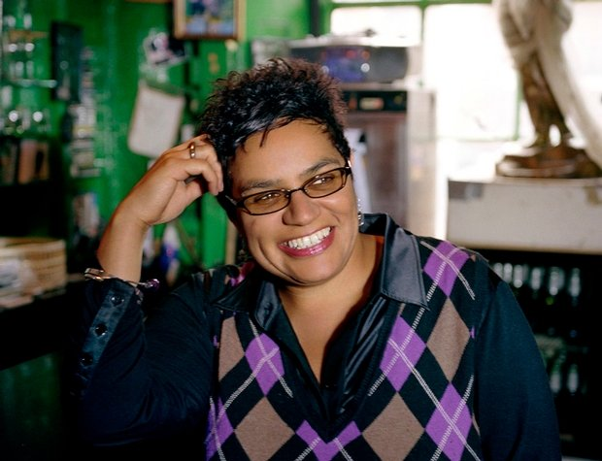
Dae Ye Ken……. Jackie Kay (Born 1961) The current Scots Makar (Scotland’s National Poet) is a poet, playwright, and novelist. Kay was adopted by a white Scottish couple at an early age, growing up in a household where political activism was prevalent. The issues of cultural identity and social justice that her childhood instilled in her became recurring themes in Kay’s verse.

Answers to Funny Wummin (Page 19)

Photo’s on the top of the page, left tae right
Jane McCarry, Susan Calman, Janey Godley, Elaine C. Smith, Karen Dunbar
Photo’s on the bottom of the page, left tae right
Dorothy Paul, Doon Mackichan, Rhona Cameron, Janette Tough, Sharon Rooney

Grateful thanks to Elizabeth Bryan for allowing us to adapt and use her Women’s Suffrage resources.

Thanks also to the National Library of Scotland
The images of the 1909 Edinburgh Women’s Suffrage Procession, Flora Drummond, WSPU leaders arriving in the city to watch the procession are taken from a set of original postcards kept in a WSPU album donated to the National Library of Scotland by the Edinburgh suffragette, Elizabeth Gorrie (1891-1973) (Acc.4546).
The National Library of Scotland has a range of items relating to the campaigns for women’s suffrage in Scotland. Some of these items have been digitised and can be viewed in the link here: https://digital.nls.uk/suffragettes/sources.html

Find the Scots Wurds
N | N | K | W | G | E | N | I | M | M | U | W | F | P | R
I | Z | H | B | G | N | A | R | T | S | Q | V | D | N | R
B | A | V | H | D | O | U | C | H | T | F | R | E | E | N
I | T | W | I | S | T | I | T | H | D | P | E | G | T | P
D | I | E | H | C | A | R | F | U | F | F | L | E | T | L
D | O | K | C | T | L | D | K | N | Y | M | T | T | E | L
Y | S | B | Y | I | S | O | L | R | M | E | A | S | S | E
T | E | L | D | V | U | I | E | U | I | B | M | F | F | N
I | N | I | M | D | H | T | G | S | A | E | U | D | Y | S
K | I | T | Z | C | H | A | S | A | D | B | X | Z | S | X
I | U | H | F | C | L | A | F | D | R | E | H | T | I | M
A | Q | E | E | L | L | L | U | R | O | F | B | W | V | K
L | H | F | U | K | S | M | P | P | U | B | F | L | U | D
G | G | S | J | M | R | S | G | N | I | J | A | U | E | Q
S | U | F | F | R | A | G | E | T | T | E | S | Z | S | S

FECHTER  WUMMIN  CARFUFFLE  BAULD  QUINES  SMEDDUM  FREEN  SETTEN  DOUCHT  BLITHE  MITHER | LASSIE  SUFFRAGIST  SUFFRAGETTES  GLAIKIT  NIBIDDY  TWISTIT  JINGS  SNELL  STRANG  GALLUS  hEID

Yer Say…….Feedback

Once again, thank you to everyone who takes time to give feedback.

Jenny Miller from the Dove Centre said, “I've been making support calls all day and several of our service users were telling me how they've been enjoying the latest Guid Fer A Laugh pack.”

"Oh, that Guid Fer A Laugh was so comical! I even took it to my bed to read (and it's not like me to do that!), and I've now read it cover to cover! I've kept all the books so far and I've learned about words and expression I've never heard of. Makes things so much more interesting. I think they're absolutely brilliant, I've had such a giggle to myself." - Lily, Dove Centre Service User

"Guid Fer A Laugh reminded me of all the games we used to play to the rhymes, for example skipping ropes, peevery beds, postie postie and I loved the one about the pyjamas! It was such a laugh and I thoroughly enjoyed it. It was a right memory day yesterday! Please pass my thanks on to Lydia!" Margaret M, Dove Centre Service User

Kim Sibbald, Edinburgh & Lothian Greenspace Trust sent us the following: “We had a very educational catch up our Thursday zoom session today. We discussed Scots words such as gullie, drookit, puddock, glakit & dwam! We talked about girnel, messages, shivery bite, bunker, skullery and my absolute fav.... jeelie piece! Do you know the meanings of all these words? Have I spelled them right?

We’d like to say “HELLO” to Sheila Richards from her sister Linda & brother in law Stuart from the Oxgangs Walking group. We are glad to hear that you enjoy going over the pack with your sister Linda. We hope you enjoy our March pack which celebrates Scots Wummin. You can let us know what you think aboot it.

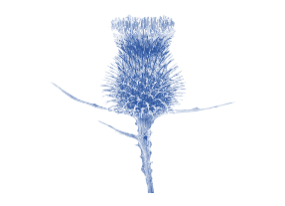
Hae Yer Say P

For April’s edition we are once again teaming up with Age Scotland, the theme is Spring/Nature. If you’ve got anything you would like to send, my email and phone number are below.

- Did you enjoy it? If yes, what did you like?

- If not, why not?

- Anything else you would like to see in the pack?

Course material developed by Derek Suttie, Scots Literacy Tutor
Send your Scots words, jokes, poems, sayings, suggestions to:

Lydia.markham@ea.edin.sch.uk Mobile: 07719 420 424
Lydia Markham, Lifelong Learning Worker (Adult Learning),
SW Locality, City of Edinburgh Council

