 | 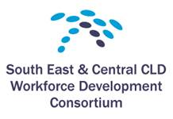

“Communities Empowered - Making it Real”
A Skills Seminar with Steve Skinner

9.15am Arrival and Registration

9.45pm Introduction

10.00pm Alasdair McKinlay - Head of Community Empowerment and Community Planning (Scottish Government)

10.30pm The Four Building Blocks for Community Capacity Building and the Community Empowerment Act (Steve Skinner)
- Building the Skills of Groups

11.15am Tea/Coffee break

11.30am The Four Building Blocks for Community Capacity Building and the Community Empowerment Act. (cont.)
- Building Organisations
- Building Involvement
- Building Equality

12.45pm Lunch

1.30pm The Skills and Roles of Practitioners (Steve Skinner)

3.10pm The Wider Picture of Community Empowerment (Steve Skinner)

4.10pm Summarising Our Day (Steve Skinner)

4.15pm Evaluation and Next Steps (Diann Govenlock)

4.30pm Finish

Hope you enjoyed it...... and thanks for coming!

