CLD volunteers do amazing things …. There’s HMI evidence to prove it!
To help CLDSC know more about CLD volunteers and how we can better support them, we have reviewed HMI inspection reports to see what they say about volunteers. The experience, skills and commitment of CLD volunteers and the impact of their contribution is highlighted again and again. Volunteers Week is the ideal time to get our review out there and to tell the story of our great volunteers, what they do and how we can help them.
What HM inspectors are saying about volunteering in CLD
The reports produced by HMI following their inspections of CLD provide an evaluative picture of CLD volunteering in local communities across Scotland. Reviewing these reports from a CLD volunteering perspective has helped develop our understanding of CLD volunteers and their needs. We hope the findings will be of assistance to colleagues in the sector who deploy volunteers in a CLD setting.
1 The Reports
The current model of inspection (September 2016) includes a focus on impact on staff and volunteers, specifically, the extent to which they ‘reflect on and improve practice through regular access to relevant high quality learning and development and are developing leadership capacity.’ To help answer this question, CLD inspectors met with volunteers during the ‘place based’ element of the inspection.
At the time this review was last updated (May 2019) 30 reports had been published.
2 The Review Process
The review looked at references to volunteers and volunteering in the published reports. These comments were categorised as follows:
- strengths and positive comments about CLD volunteers/volunteering
- positive comments about professional learning (PL)
- improvement needed
- positive comments about volunteering generally.
3 Strengths
At the conclusion of their reports HMI record the key strengths identified during the inspection.
HMI identified aspects of volunteering as a key strength in 14 of the 30 inspection reports reviewed. Aspects of volunteering were cited as a strength twice in one report and three times in another.
Of these strengths 9 were specifically about CLD volunteers and volunteering, for example, ‘volunteers increasing learning opportunities in their community’.
A further 8 could be interpreted as including more generic volunteering alongside CLD volunteers, for example, ‘highly effective community organisations and volunteers’.
The 17 strengths identified 28 positive attributes which could be categorised broadly as follows:
14 referred to the effectiveness and impact of volunteering
eg ‘well established culture of volunteering and community involvement increasing the learning offer and improving communities’
9 highlighted the experience, skills and commitment of volunteers
eg ‘experienced, skilled and responsive (staff and) volunteers who use networks very effectively to improve provision
5 referred to the quality of support to volunteers and/or a culture of volunteering
Eg ‘Effective support to volunteering’
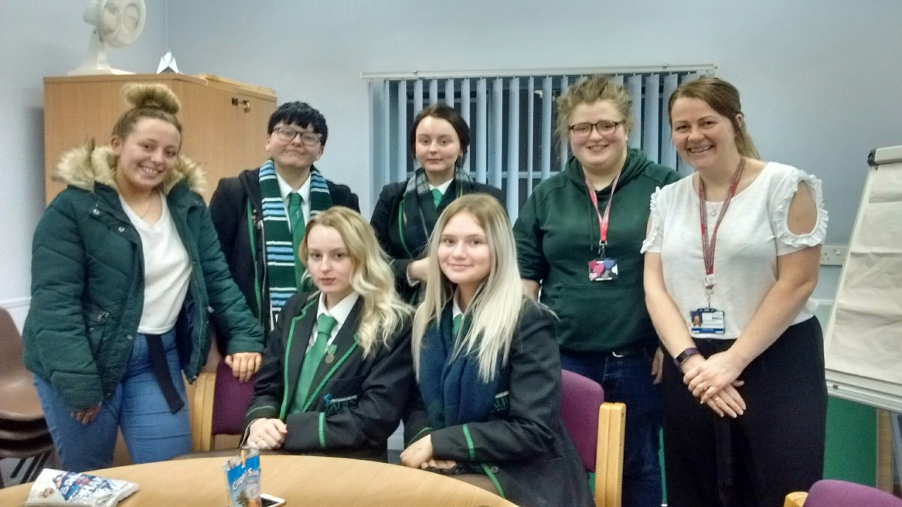
4 Positive comments about CLD volunteers and volunteering
In addition to the positive attributes identified as strengths above, 27 of the 30 reports included positive comments about CLD volunteers and CLD volunteer activity. A further 30 positive aspects were highlighted:
11 of these noted the skills, experience and enthusiasm of CLD volunteers
Eg ‘committed and enthusiastic community organisations and volunteers extend the learning offer’
13 praised the effective contribution of CLD volunteers
Eg ‘Community groups and volunteers deliver valued social and learning opportunities which increase the quality of life in the area.’
6 highlighted the effective support of CLD volunteers
Eg ‘Many programmes and activities are supported by skilled, knowledgeable and confident volunteers who are well supported in their role’.
5 Positive comments about professional learning for CLD
During their inspections HMI ‘looked at how well paid staff and volunteers are developing their own practices and building capacity.’ This resulted in a number of positive comments about professional learning opportunities.
From a CLD Standards Council perspective, the extent to which volunteers are accessing professional learning is also of particular interest.
The review identified and collated comments where volunteers were included in a positive reference to professional learning.
There were 46 positive references to PL in 24 of the 30 reports.
23 of these references noted a good range and/or the regular provision of professional learning opportunities
eg ‘high quality workforce development opportunities increase the capacity of staff and volunteers across’ the area
14 praised the confidence building and support available to volunteers
Eg CLD partners provide high quality support to volunteers. As a result nearly all volunteers feel valued and engaged.’
9 noted that PL opportunities were shared across partnerships
Eg ‘Shared training and networking is improving as a result of partnership working’
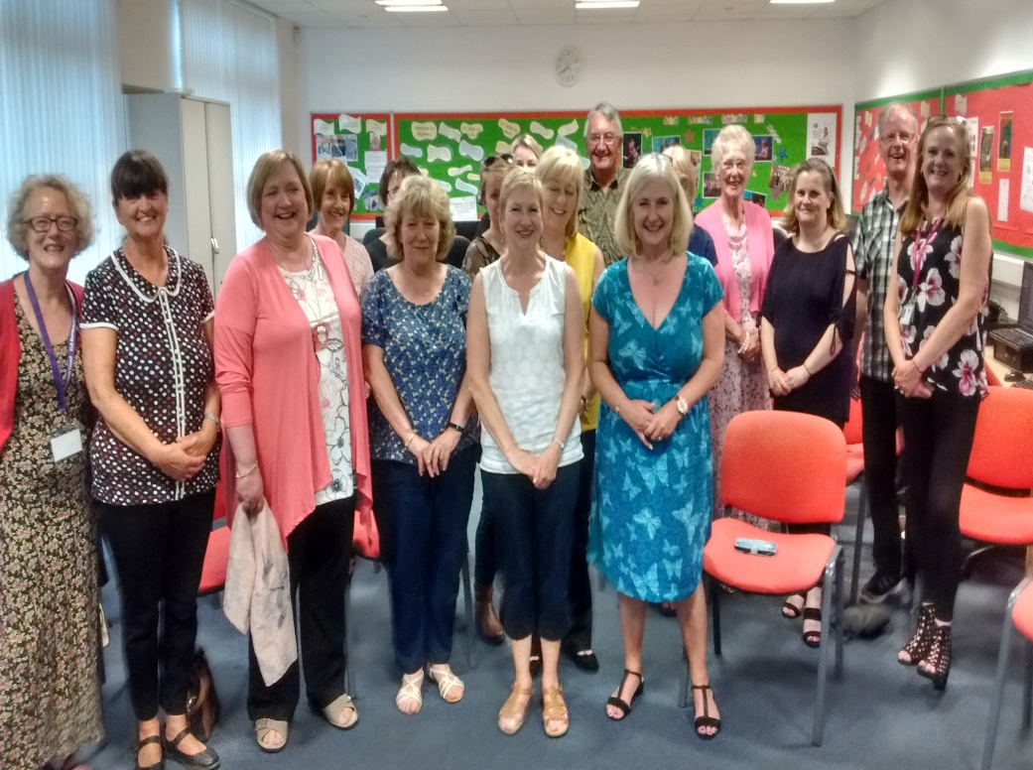
6 Improvement needed
At the conclusion of an inspection, HMI discuss with partners how they might continue to improve their work. The agreed areas for improvement are identified in each report. Of the 29 reports reviewed only one of these agreed areas of improvement made reference to volunteers or volunteer activities.
This recommended the CLD Partnership: ‘Improve the consistency of support to community organisations and volunteers.’
The review did, however, identify and collate comments where an aspect of volunteering was identified as needing to be improved.
In 18 of the 30 reports reviewed, aspects relating to CLD volunteering were identified for improvement. In some reports more than one aspect for improvement was identified.
The 25 aspects requiring improvement broadly fall into 3 categories:
13 referred to the co-ordination and provision of professional learning and opportunities to share practice
eg ‘(staff and) volunteers would benefit from partners now working together to better co-ordinate and develop the training offer’
6 highlighted the need to capture the extent and impact of CLD volunteering
eg ‘the CLD partnership should now consider capturing the value and impact of volunteering more robustly’
4 recommended that volunteering should be recognised and celebrated more fully
A further 2 references were about the recruitment of additional volunteers and the involvement of volunteers in decision making.
7 Positive comments about volunteering generally
The review identified a number of positive comments and good examples which could be attributed to other types of volunteers as well as to CLD volunteers.
Some of these are listed below to illustrate the wide impact of volunteer activity in CLD settings.
- Run activities, contribute to services
- Support community members to address challenges in their lives, build resilience
- Thriving sense of place
- Young volunteers gaining leadership awards
- Enhance community life
- Make a positive contribution to a socially diverse community
- Reflect community need
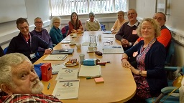
Reflective Questions
The following questions are intended to encourage those who deploy volunteers in CLD to reflect on their policies and procedures to identify ways in which CLD volunteers can be better supported to make a difference in their communities.
14 reports highlight the impact made by CLD volunteers as a strength. 6 CLD Partnerships were recommended to improve the way they capture the value and impact of CLD volunteer activity.
How do you evidence and evaluate the impact of your volunteers? Could this be improved?
23 reports make positive comments about the range and regular provision of Professional Learning for CLD volunteers. A further 9 reports noted where this is provided effectively across partnerships.
What is the PL offer to your volunteers? Would this provision be enhanced by being planned and delivered across the CLD partnership?
‘CLD Partners provide high quality support to volunteers. As a result, nearly all volunteers feel valued and engaged’. This and similar positive comments were made in 14 reports.
How recently have you reviewed the quality of your support to volunteers? To what extent are volunteers themselves involved in planning and giving feedback on the support they receive? Do your volunteers feel valued?
How the CLD Standards Council can help ….
- The Associate category of CLDSC membership is open to volunteers and provides a vehicle for them to consider the Code of Ethics and the CLD competencies which underpin their practice.
- The CLDSC publication ‘Growing the Learning Culture’ provides a framework for developing professional learning for both staff and volunteers.
- CLDSC Standards Mark provides quality assurance for the professional learning provided by organisations.
- The Volunteer Theme on i-develop contains a number of examples and good practice guides on the effective deployment of CLD volunteers.
- Maggie Paterson, a volunteer with CLDSC, is available to talk to groups of CLD volunteers and/or organisations who deploy them about the CLDSC offer to volunteers.

