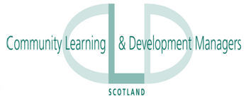

Community Learning and Development Managers Scotland Annual Conference will take place on Tuesday 31 October 2017, in the Best Western Lovat Hotel, Glasgow Road Perth PH2 0LT

The Theme for this year’s conference is

Community Learning and Development’s Role in Promoting Leadership and Creativity

The conference will be of interest to staff and managers involved in all sectors of community learning and development, including Local Authority Services, Further Education, Community Planning, Voluntary and Third Sector Organisations

A day delegate rate of £50 will include refreshments on arrival and lunch.

[BOOK HERE](https://www.youthlinkscotland.org/events/october-2017/community-learning-and-development-managers-scotland-annual-conference/book-now/)

An arrangement has also been made with the hotel to reserve a number of bedrooms for delegates wishing to travel to the venue on the Monday.

The charge for bed and breakfast is £65 and individuals wishing to use this facility should liaise directly with the hotel for booking and payment no later than **Thursday 31** **August 2017.**

To make a hotel reservation please call 0844 387 6119