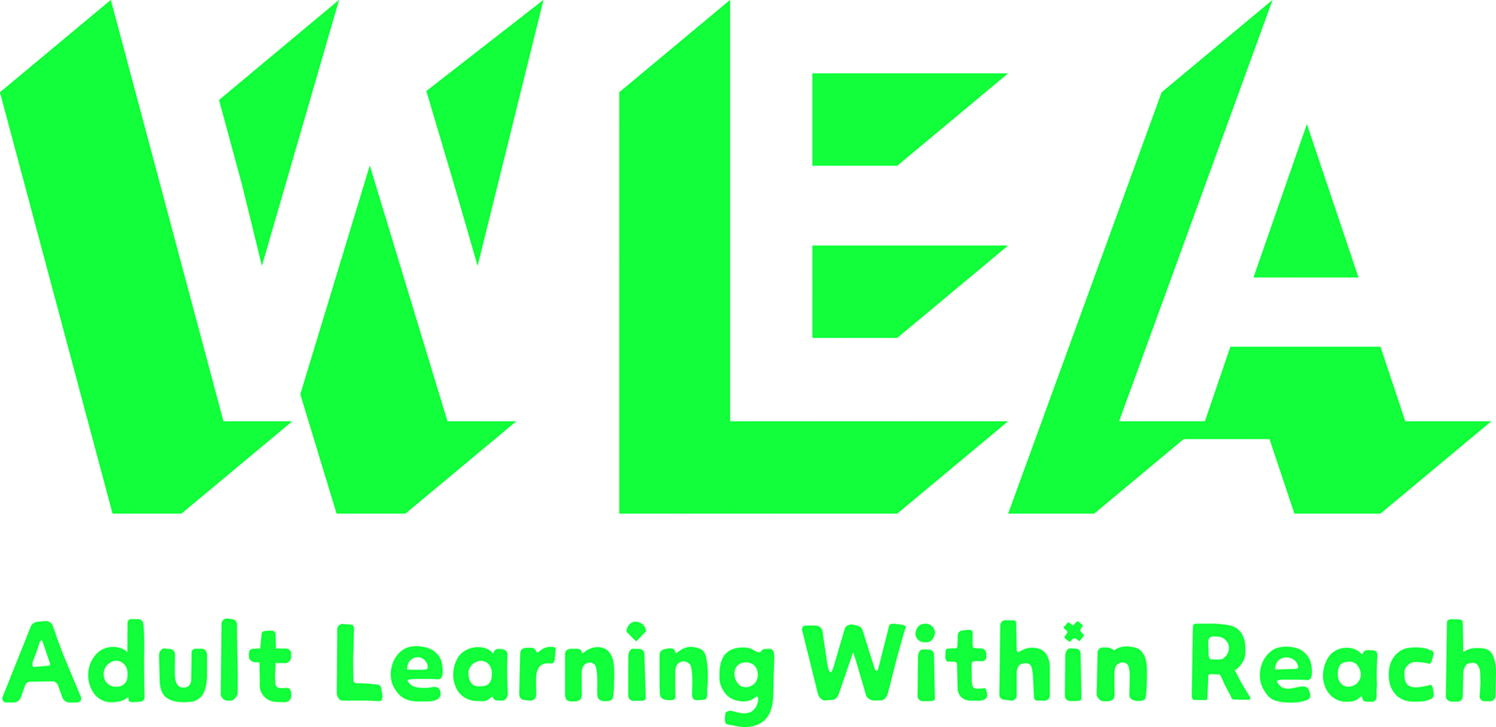
Community Learning and Development and STEM
Are you an adult learning tutor?
Have you ever worked with learners on subjects such as the environment, cooking, using data, transport or family learning?
You might also have used digital technology or teach numeracy, maths or science subjects.
Learning Link Scotland in conjunction with the Workers' Educational Association and Glasgow Science Centre would like to hear your ideas and experiences of using science in adult education.
You may have no experience or lots of experience but we would love to hear your ideas via our quick survey, please follow this link:
Adult learning and science survey
We are also holding a focus group to discus science in adult education on 18th January in Glasgow Science Centre.
The session is open to all adult education tutors to find out your views on science and adult education. We want to find out the barriers, the possibilities and the practicalities of using science with adults.
During the focus group we will hold a discussion and then take the opportunity to explore some of the resources provided in Glasgow Science Centre.
Please register your interest in this event here: Registration for focus group

For more information please contact Jackie Howie jhowie@learninglinkscotland.org.uk

